PARTY MASTER
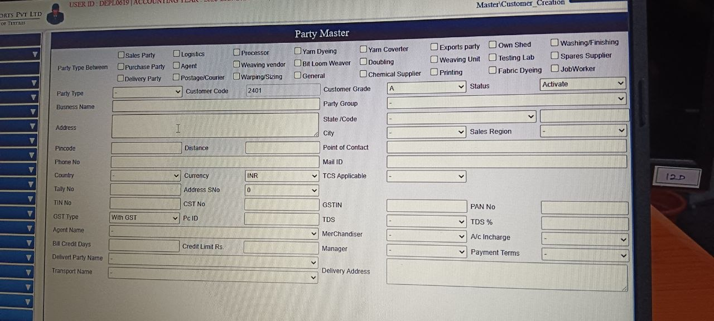
Purpose
- Centralized records: Maintain a single source of truth for all parties involved in business operations.
- Compliance management: Store tax IDs (GST, PAN, TIN, CST) and ensure legal adherence.
- Financial control: Track credit limits, payment terms, and billing cycles.
- Operational efficiency: Streamline communication, logistics, and accounting by having all details in one place.

Main Functions
- Party categorization: Classify parties (Sales, Purchase, Agent, Vendor, Processor, etc.) for easy filtering and reporting.
- Business details entry: Capture company name, address, region, and contact information.
- Tax information management: Record GSTIN, PAN, TIN, CST, and GST type for compliance.
- Financial tracking: Manage credit days, credit limits, tally numbers, and payment terms.
- Contact management: Store phone numbers, emails, and point-of-contact details.
- Logistics integration: Include delivery party names, transport details, and delivery addresses.
- Role assignment: Assign responsibility to Merchandisers, Managers, and Accounts Incharge.

Field Name | Data Type | What Data Should Be Added
Party Type | Dropdown | Select role: Sales Party, Purchase Party, Logistics, Agent, etc.
Customer Code | Auto-generated number | System-generated unique ID (e.g., 2401).
Customer Grade | Dropdown | Grade classification (A, B, C) based on importance/volume.
Status | Dropdown | Activate or Deactivate depending on whether party is active.
Business Name | Text | Full legal/trade name of the company.
Party Group | Dropdown | Select grouping category (e.g., “Textile Suppliers”).
Address | Text | Complete postal address.
State/Code | Dropdown | Select state and code (e.g., TN / 33).
Pincode | Numeric | Postal code (e.g., 637211).
City | Dropdown | Select city name (e.g., Tiruchengodu).
Phone No | Numeric/Text | Contact number with STD code.
Sales Region | Dropdown | Select region (e.g., South Zone, North Zone).
Country | Dropdown | Select country (e.g., India).
Currency | Dropdown | Default currency (INR, USD, etc.).
Point of Contact | Text | Name of the person handling communication.
Mail ID | Text | Official email address.
Tally No | Text | Code/ID used in Tally ERP integration.
Address SNo | Dropdown | Sequence number if multiple addresses exist.
TCS Applicable | Dropdown | Yes/No depending on tax applicability.
TIN No | Text | Tax Identification Number (if applicable).
CST No | Text | Central Sales Tax number (legacy field).
GSTIN | Text | GST registration number (15-digit alphanumeric).
GST Type | Dropdown | With GST / Without GST.
PAN No | Text | Permanent Account Number (10-digit alphanumeric).
TDS | Dropdown | Applicable TDS section (e.g., 194C).
TDS % | Numeric | Deduction percentage (e.g., 1%, 10%).
Pc ID | Text | Internal party code for tracking.
Merchandiser | Dropdown | Select merchandiser from employee list.
Manager | Dropdown | Select manager responsible.
Bill Credit Days | Numeric | Number of days allowed for credit (e.g., 30).
Credit Limit Rs. | Numeric | Maximum credit allowed (e.g., 5,00,000).
A/c Incharge | Dropdown | Select employee responsible for accounts.
Deliver Party Name | Dropdown | Select delivery party from master list.
Payment Terms | Dropdown | Select terms (e.g., Net 30, Advance, COD).
Transport Name | Dropdown | Select transporter (e.g., VRL Logistics).
Delivery Address | Text | Address for delivery of goods.
Agent Name | Dropdown | Select agent handling the party.
Dropdown Fields Reference
Dropdown Field | What Data Should Be Added | Where It Connects
Party Type | Sales Party, Purchase Party, Logistics, Agent, etc. | Party Type Master
Customer Grade | A, B, C (classification) | Customer Grade Master
Status | Activate / Deactivate | Status Master
Party Group | Suppliers, Agents, Customers, Logistics Partners | Party Group Master
State Code | TN-33, KA-29, MH-27, etc. | State Master
City | Tiruchengodu, Erode, Coimbatore, Salem | City Master
Sales Region | South Zone, North Zone, East Zone, West Zone | Sales Region Master
Country | India, Bangladesh, Sri Lanka, USA | Country Master
Currency | INR, USD, EUR, GBP | Currency Master
Address SNo | 1, 2, 3 (sequence for multiple addresses) | Address Master
TCS Applicable | Yes / No | Tax Rules Master
GST Type | With GST / Without GST | GST Configuration Master
TDS | 194C (Contractor), 194J (Professional), 194H (Commission) | Tax Master
Merchandiser | Employee names (e.g., Ramesh, Priya) | Employee Master
Manager | Employee names (e.g., Suresh, Anitha) | Employee Master
A/c Incharge | Accountant staff names | Employee/User Master
Deliver Party Name | Warehouse A, Depot B | Delivery Party Master
Payment Terms | Net 30, Net 60, Advance, COD | Payment Terms Master
Transport Name | VRL Logistics, SafeExpress, Local Transporter | Transport Master
Agent Name | Kumar Agencies, Shree Traders | Agent Master
Matches Between Party Master Dropdowns & Screenshot Menus

Party Master Dropdown Field | Screenshot Menu Option | Connection
Party Type | Party Type | Defines whether party is Sales, Purchase, Agent, etc.
Customer Grade | (Not shown in screenshot) | Internal grade master
Status | (Not shown in screenshot) | Internal status master
Party Group | Party Group | Groups like Suppliers, Agents, Customers
State Code | District & City | State codes linked to GST compliance
City | District & City | City names maintained in master
Sales Region | Sales Region | Regional zones (South, North, etc.)
Country | Country | Country master list
Currency | Currency | INR, USD, EUR, etc.
Address SNo | Address Master (not shown, but part of Sub Masters) | Sequence for multiple addresses
TCS Applicable | Tax Rules Master (not visible here) | Yes/No flag
GST Type | GST Configuration (not visible here) | With GST / Without GST
TDS | Tax Master (not visible here) | Sections like 194C, 194J
Merchandiser | Merchandiser | Employee list
Manager | Manager | Employee list
A/c Incharge | A/C Incharge | Employee/User master
Deliver Party Name | Delivery Party Master (not visible here, but part of Sub Masters) | Warehouse/Depot names
Payment Terms | Payment Terms / Payment Term & Conditions | Net 30, Advance, COD
Transport Name | Transport Master | VRL Logistics, SafeExpress
Agent Name | Agent / Buyer | Agent master list
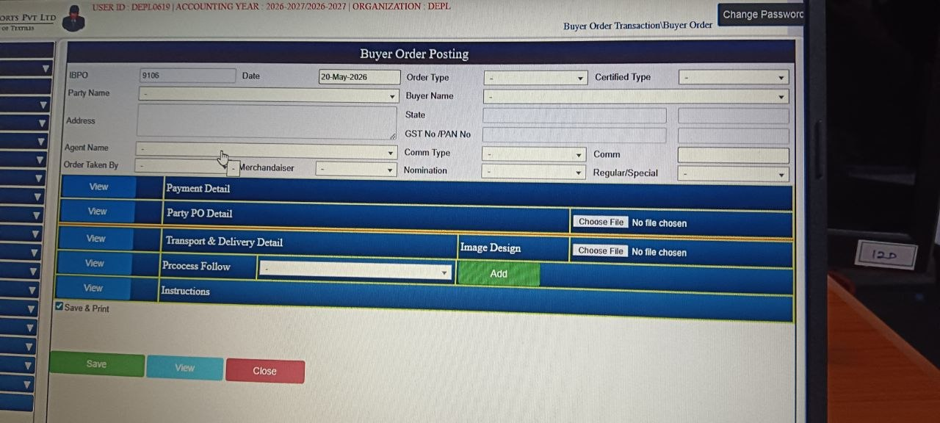
Buyer Order Posting

Purpose
- Order management: Centralize buyer order details for accuracy and easy retrieval.
- Financial compliance: Capture GST, PAN, commission, and payment terms for legal and accounting purposes.
- Process coordination: Link order details with logistics, agents, and production processes.
- Documentation: Maintain records for audits, buyer communication, and export documentation.

Main Functions
- Order entry: Input IBPO number, date, buyer name, agent name, and party details.
- Buyer details: Store address, state, GST No, PAN No, and nomination type.
- Payment detail management: Define payment terms, commission type, and financial arrangements.
- Party PO detail: Record buyer’s purchase order references for traceability.
- Transport & delivery: Capture logistics details like transport mode and delivery address.
- Process follow: Track production or processing steps linked to the order.
- Instructions handling: Allow special buyer instructions to be stored and viewed.
- Design file upload: Attach image designs or order-related documents.
- Save & print: Save the order digitally and generate a printed copy for records or dispatch.
Buyer Order Posting – Field Types

Field Name | Field Type | What Data Should Be Added
IBPO Number | Auto-generated / Numeric | System-generated order number (e.g., 9106)
Date | Date Picker | Order posting date (e.g., 20-May-2026)
Party Name | Dropdown | Select party from Party Master
Address | Text | Party’s full address
Agent Name | Dropdown | Select agent from Agent Master
Order Type | Dropdown | Regular, Export, Special
Certified Type | Dropdown | ISO, Organic, Fair Trade, etc.
Buyer Name | Dropdown | Select buyer from Buyer Master
State | Dropdown | TN-33, KA-29, MH-27, etc.
GST No / PAN No | Text | Tax identifiers (GSTIN, PAN)
Commission Type | Dropdown | Percentage / Fixed
Commission | Numeric | Commission value (e.g., 5%)
Order Taken By | Dropdown | Employee name from Employee Master
Nomination | Text | Nomination details if applicable
Regular / Special | Dropdown | Select Regular or Special classification
Payment Detail | Linked Section | Opens Payment Terms sub-form
Party PO Detail | Linked Section | Buyer’s purchase order details
Transport & Delivery Detail | Linked Section | Transporter and delivery info
Process Follow | Linked Section | Process sequence details
Instructions | Linked Section | Special instructions
Image Design | Linked Section | Attach design files
Save / View / Close Buttons | Action Buttons | Save, view, or close the order
Save & Print Checkbox | Checkbox | Save and immediately print
Buyer Order Posting – Dropdown Fields

Dropdown Field | What Data Should Be Added
Party Name | Select party/customer from Party Master
Agent Name | Select agent handling the order
Order Type | Regular, Export, Special
Certified Type | ISO, Organic, Fair Trade, etc.
Buyer Name | Select buyer company/person
State | TN-33, KA-29, MH-27, etc.
Commission Type | Percentage / Fixed
Order Taken By | Employee name (e.g., Merchandiser)
Regular / Special | Regular / Special classification
Buyer Order Posting Dropdowns (Matched vs Not Matched)
Buyer Order Posting Dropdown | Match in Screenshots | Where It Connects
Party Name | ✅ Seen in Party Master menu | Party Master
Agent Name | ✅ Seen as Agent / Buyer | Agent Master
Order Type | ✅ Seen as Order Type | Order Type Master
Certified Type | ✅ Seen as Certified Type | Certified Type Master
Buyer Name | ✅ Seen as Buyer | Buyer Master
State | ✅ Seen as District & City | State Master
Commission Type | ❌ Not visible in screenshots | Commission Type Master
Order Taken By | ✅ Seen as Manager / Merchandiser | Employee Master
Regular / Special | ❌ Not visible in screenshots | Order Classification Master
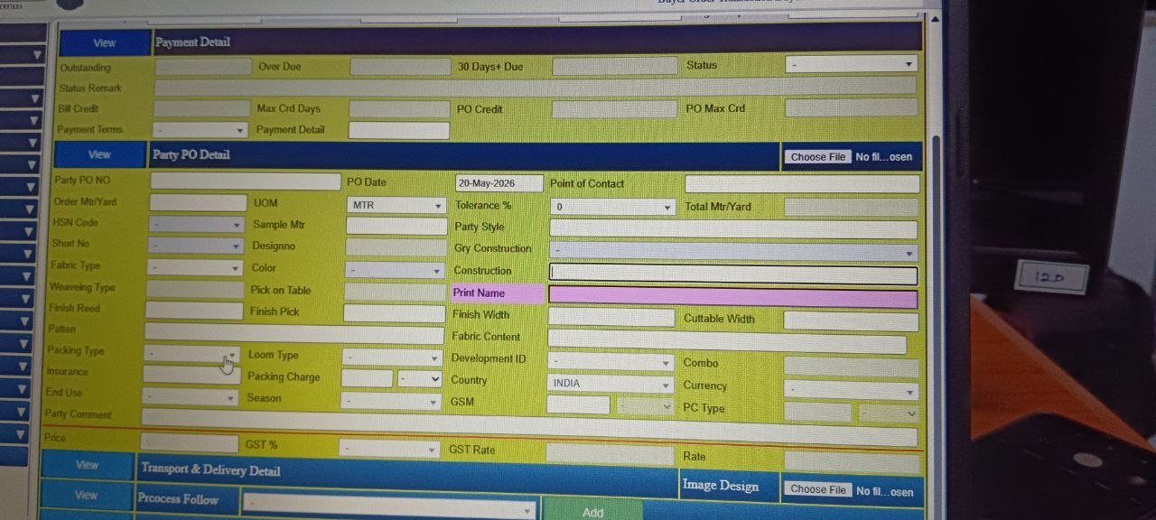
Payment Details and Party PO Details
Purpose
- Payment tracking: Monitor outstanding amounts, overdue bills, and credit terms.
- Purchase order management: Record buyer PO details, dates, and references for traceability.
- Product specification: Capture fabric type, construction, GSM, weaving type, finish, and other technical details.
- Financial compliance: Apply GST %, rates, and ensure proper tax handling.
- Logistics coordination: Link PO with transport, delivery, and packing details.

Main Functions
- Payment detail section: Tracks outstanding dues, overdue bills, credit days, and payment terms.
- Party PO detail: Records PO number, date, order quantity, tolerance %, HSN code, and buyer style references.
- Fabric specifications: Inputs details like fabric type, construction, weaving type, GSM, finish width, cuttable width, loom type, and fabric content.
- Design & style details: Captures print name, pattern, season, combo, and end use.
- Price section: Defines GST %, GST rate, and base rate for billing.
- Packing & insurance: Includes packing type, charges, and insurance details.
- Additional comments: Allows entry of buyer-specific instructions or remarks.
Payment Detail Section

Field Name | Field Type | What Data Should Be Added
Outstanding | Numeric | Amount pending
Over Due | Numeric | Amount overdue
30 Days+ Due | Numeric | Amount overdue beyond 30 days
Status | Dropdown | Active / Inactive / Settled
Status Remark | Text | Notes about payment status
Max Crd Days | Numeric | Maximum credit days allowed
PO Credit | Numeric | Credit days for this PO
PO Max Crd | Numeric | Maximum credit for this PO
Bill Credit | Numeric | Credit days for billing
Payment Detail | Text | General notes
Payment Terms | Dropdown | Net 30, Net 60, Advance, COD
Choose File | File Upload | Attach supporting document
Payment terms comes from the sub master module:
Payment Terms | Payment Terms / Payment Term & Conditions

Party PO Detail Section
Field Name | Field Type | What Data Should Be Added
Party PO No | Text | Buyer’s PO number
PO Date | Date Picker | Date of PO (e.g., 20-May-2026)
Point of Contact | Text | Name of contact person
Order Mtr/Yard | Numeric | Ordered quantity
UOM | Dropdown | MTR, YARD, PCS
Tolerance % | Numeric | Allowed tolerance percentage
Total Mtr/Yard | Numeric | Total ordered quantity
HSN Code | Dropdown | Select HSN code from master
Sample Mtr | Numeric | Sample quantity
Party Style | Text | Style reference
Short No | Text | Short number reference
Design No | Text | Design reference
Gry Construction | Text | Grey fabric construction
Fabric Type | Dropdown | Cotton, Polyester, Blended
Color | Dropdown | Color master list
Construction | Text | Fabric construction details
Weaving Type | Dropdown | Plain, Twill, Satin
Pick on Table | Numeric | Pick count
Print Name | Text | Print design name
Finish Reed | Numeric | Reed count after finishing
Finish Pick | Numeric | Pick count after finishing
Finish Width | Numeric | Finished width
Cuttable Width | Numeric | Cuttable width
Pattern | Dropdown | Stripe, Check, Solid
Packing Type | Dropdown | Bale, Box, Roll
Loom Type | Dropdown | Loom type master
Insurance | Dropdown | Yes / No
Packing Charge | Numeric | Packing cost
End Use | Dropdown | Apparel, Home Textile, Industrial
Season | Dropdown | Summer, Winter, All Season
Party Comment | Text | Remarks from party
Fabric Content | Text | Fiber composition
Development ID | Text | Internal development reference
Country | Dropdown | India, Bangladesh, USA
Combo | Text | Combo reference
Currency | Dropdown | INR, USD, EUR
PC Type | Dropdown | Type of PC (internal classification)
GSM | Numeric | Fabric GSM
Price | Numeric | Price per unit
GST % | Numeric | GST percentage
GST Rate | Numeric | GST rate
Rate | Numeric | Final rate
Image Design | File Upload | Attach design file
Party PO Detail – Complete Field Types
Field Name | Field Type | What Data Should Be Added / Where It Connects
UOM | Dropdown | Unit of Measure → MTR, YARD, PCS (UOM Master)
HSN Code | Dropdown | Harmonized System Code for fabric (HSN Code Master)
Fabric Type | Dropdown | Cotton, Polyester, Blended, Silk (Fabric Type Master)
Color | Dropdown | Standard color list (Red, Blue, Green, etc.) (Color Master)
Weaving Type | Dropdown | Plain, Twill, Satin, Jacquard (Weaving Master)
Pattern | Dropdown | Stripe, Check, Solid, Printed (Pattern Master)
Packing Type | Dropdown | Bale, Box, Roll (Packing Master)
Loom Type | Dropdown | Power Loom, Hand Loom, Auto Loom (Loom Master)
Insurance | Dropdown | Yes / No (Insurance Master)
End Use | Dropdown | Apparel, Home Textile, Industrial (End Use Master)
Season | Dropdown | Summer, Winter, All Season (Season Master)
Country | Dropdown | India, Bangladesh, USA, EU (Country Master)
Currency | Dropdown | INR, USD, EUR, GBP (Currency Master)
PC Type | Dropdown | Internal classification (e.g., PC1, PC2) (PC Type Master)
Short No | Text | Entered manually (style/short reference). Not dropdown.
Tolerance % | Numeric | Enter tolerance percentage (e.g., 0, 5%). Not dropdown.
Grey Construction | Text | Enter construction details of grey fabric. Not dropdown.
Development ID | Text | Internal development reference code. Not dropdown.
Packing Charge | Numeric | Enter cost value. Not dropdown.
GSM | Numeric | Enter fabric GSM (weight per sq. meter). Not dropdown.
Party PO Detail – Match vs Not Match
Field Name | Field Type | Match Status | Where It Connects
UOM | Dropdown | ✅ Matched | UOM Master
HSN Code | Dropdown | ✅ Matched | HSN Code Master
Fabric Type | Dropdown | ✅ Matched | Fabric Type Master
Color | Dropdown | ✅ Matched | Color Master
Weaving Type | Dropdown | ✅ Matched | Weaving Master
Pattern | Dropdown | ✅ Matched | Pattern Master
Packing Type | Dropdown | ✅ Matched | Packing Master
Loom Type | Dropdown | ✅ Matched | Loom Master
Insurance | Dropdown | ✅ Matched | Insurance Master
End Use | Dropdown | ✅ Matched | End Use Master
Season | Dropdown | ✅ Matched | Season Master
Country | Dropdown | ✅ Matched | Country Master
Currency | Dropdown | ✅ Matched | Currency Master
PC Type | Dropdown | ✅ Matched | PC Type Master
Short No | Dropdown | ❌ Not Matched
Tolerance % | Dropdown | ❌ Not Matched
Grey Construction | Dropdown | ❌ Not Matched
Development ID | Dropdown | ❌ Not Matched
Packing Charge | Dropdown | ❌ Not Matched
GSM | Dropdown | ❌ Not Matched
Transport & Delivery Detail
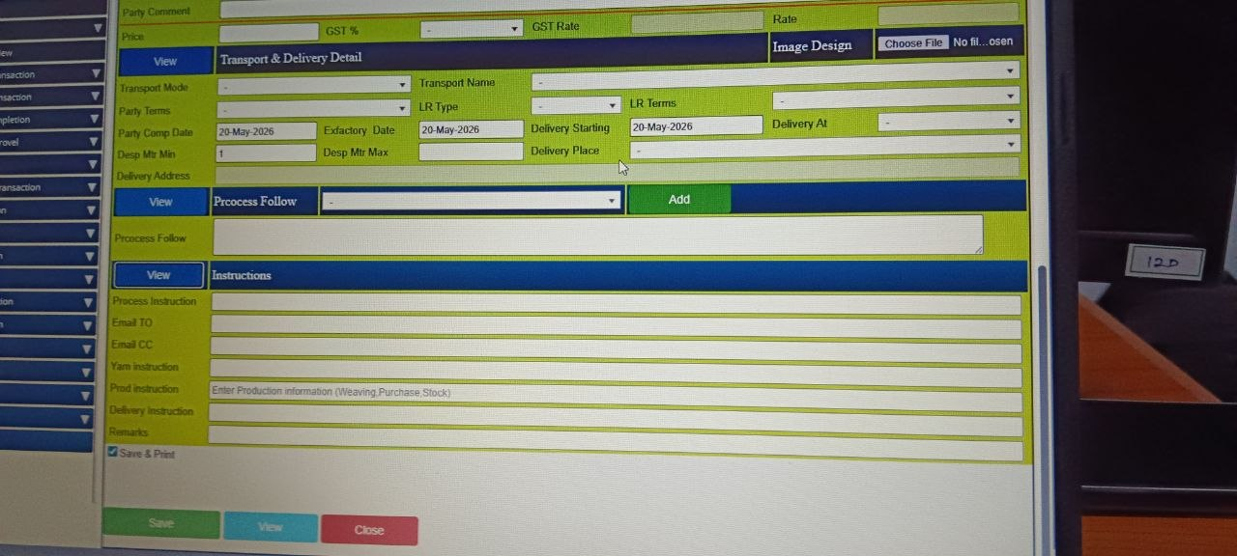
Purpose
- Logistics management: Define transport mode, delivery place, and address to streamline dispatch.
- Delivery scheduling: Record completion dates, ex-factory dates, and delivery start dates for planning.
- Process tracking: Monitor production steps and assign follow-ups.
- Instruction handling: Capture buyer-specific instructions for yarn, production, and delivery.
- Communication: Store email recipients (TO/CC) for automated updates and coordination.

Main Functions
- Transport & delivery detail:
  - Record transport mode, name, LR type/terms, delivery place, and address.
  - Track dispatch minimum/maximum meters and delivery schedules.
- Process follow:
  - Add or view process steps linked to the order.
  - Ensure production and logistics are aligned with buyer requirements.
- Instruction management:
  - Enter process instructions for internal teams.
  - Capture yarn instructions for weaving/purchase/stock.
  - Record production instructions and delivery instructions.
  - Add remarks for exceptions or special notes.
- Communication integration:
  - Use email TO/CC fields to notify relevant stakeholders.
- Save & print:
  - Save data digitally and generate printed copies for dispatch or records.
Transport & Delivery Detail

Field Name | Field Type | What Data Should Be Added / Where It Connects
Transport Mode | Dropdown | Road, Rail, Air, Sea (Transport Master)
Transport Name | Dropdown | Transporter company name (Transport Master)
Party Terms | Dropdown | FOB, CIF, Ex-Works (Terms Master)
LR Type | Dropdown | Lorry Receipt type (LR Master)
LR Terms | Dropdown | LR conditions (LR Terms Master)
Party Comp Date | Date Picker | Completion date (e.g., 20-May-2026)
Exfactory Date | Date Picker | Ex-factory date (e.g., 20-May-2026)
Delivery Starting | Date Picker | Starting date for delivery
Delivery At | Text | Delivery location
Desp Mtr Min | Numeric | Minimum dispatch quantity
Desp Mtr Max | Numeric | Maximum dispatch quantity
Delivery Address | Text | Full delivery address
Delivery Place | Text | Place of delivery
Transport & Delivery Detail – Dropdowns

Dropdown Field | What Data Should Be Added
Transport Mode | Road, Rail, Air, Sea
Transport Name | Transporter company name
Party Terms | FOB, CIF, Ex-Works
LR Type | Lorry Receipt type
LR Terms | LR conditions
Delivery Terms | Delivery conditions (e.g., Door Delivery, Warehouse, Port)
Delivery Place | Place of delivery (e.g., Factory, Depot, Customer Location)
Transport & Delivery Detail – Dropdowns (Matched vs Not Matched)
Dropdown Field | Match Status | What Data Should Be Added | Where It Connects
Party Terms | ✅ Matched | FOB, CIF, Ex-Works | Payment Terms Master
LR Terms | ✅ Matched | LR conditions | LR Terms
Transport Mode | ❌ Not Matched | Road, Rail, Air, Sea
Transport Name | ❌ Not Matched | Transporter company name
LR Type | ❌ Not Matched | Lorry Receipt type
Delivery Terms | ❌ Not Matched | Delivery conditions (Door Delivery, Warehouse, Port)
Delivery Place | ❌ Not Matched | Place of delivery (Factory, Depot, Customer Location)
Process Follow

Field Name | Field Type | What Data Should Be Added / Where It Connects
Process Follow | Dropdown + Add Button | Select process sequence (Process Sequence Master)

Instructions
Field Name | Field Type | What Data Should Be Added / Where It Connects
Process Instruction | Text | Notes for process handling
Email TO | Text | Recipient email addresses
Email CC | Text | CC email addresses
Yarn Instruction | Text | Yarn-related instructions
Prod Instruction | Text | Production info (e.g., weaving, purchase, stock)
Delivery Instruction | Text | Delivery-related notes
Remarks | Text | General remarks
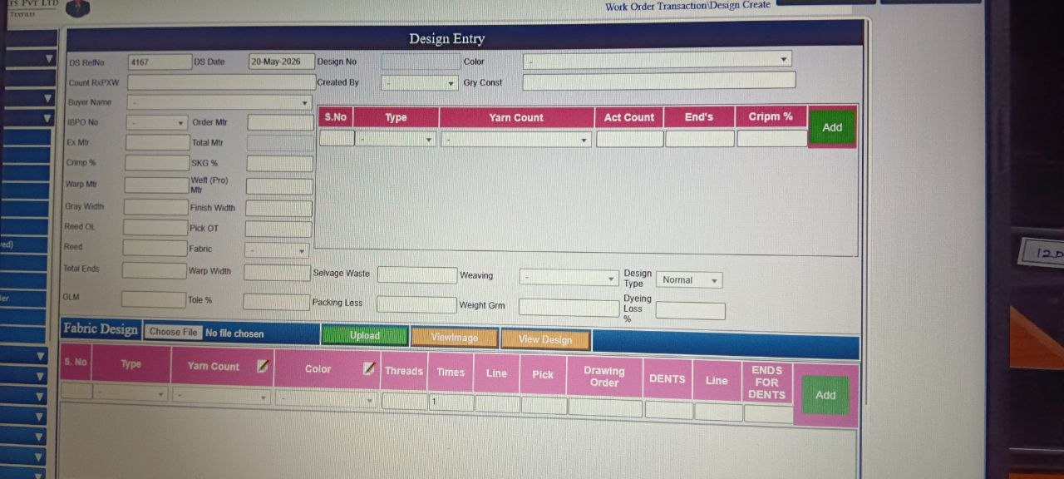
Design Entry
Purpose
- Centralized design management: Maintain a structured record of all fabric and yarn designs.
- Production alignment: Ensure weaving, dyeing, and finishing teams work with accurate specifications.
- Buyer order linkage: Connect designs directly to buyer orders for traceability.
- Quality assurance: Track tolerances, losses, and technical parameters to maintain consistency.
- Digital documentation: Store design files and images for easy retrieval and reference.

Main Functions
- Design creation: Enter new fabric/yarn designs with technical specifications.
- Design documentation: Upload and store design images/files for future use.
- Production integration: Link design details to weaving, dyeing, and finishing instructions.
- Order linkage: Associate designs with buyer orders, ISPO numbers, and order quantities.
- Quality control support: Monitor crimp %, shrinkage %, dyeing loss %, and other tolerances.
- Collaboration: Provide a shared platform for merchandisers, designers, and production teams.
- Version management: Allow updates or modifications while keeping historical records.
Design Entry – Top Section

Field Name | Field Type | What Data Should Be Added / Where It Connects
DS Ref No | Numeric | Auto-generated reference number
DS Date | Date Picker | Design entry date (e.g., 20-May-2026)
Design No | Text | Internal design number
Color | Dropdown | Standard color list (Color Master)
Created By | Dropdown | Employee name / ID
Gry Const | Text | Grey construction details
Count RxPXW | Numeric | Count specification
Buyer Name | Dropdown | Buyer list (Buyer Master)
IBPO No | Dropdown | Internal Buyer PO reference
Order Mtr | Numeric | Order quantity in meters
Ex Mtr | Numeric | Extra meters
Total Mtr | Numeric | Total quantity
Crimp % | Numeric | Crimp percentage
SKG % | Numeric | Shrinkage percentage
Warp Mtr | Numeric | Warp length
Weft (Pro) Mtr | Numeric | Weft length
Gray Width | Numeric | Grey fabric width
Finish Width | Numeric | Finished fabric width
Reed OL | Numeric | Reed overlap
Pick OT | Numeric | Picks on table
Reed | Numeric | Reed count
Fabric | Dropdown | Cotton, Polyester, Blended, Silk (Fabric Master)
Total Ends | Numeric | Ends count
Warp Width | Numeric | Warp width
QLM | Numeric | Quality length measure
Toie % | Numeric | Tolerance percentage
Selvage Waste | Numeric | Selvage waste allowance
Weaving | Dropdown | Plain, Twill, Satin, Jacquard (Weaving Master)
Design Type | Dropdown | Normal, Special, Sample (Design Type Master)
Packing Less | Numeric | Packing deduction
Weight Grm | Numeric | Fabric weight in grams
Dyeing Loss % | Numeric | Dyeing loss percentage

Yarn Table Section
Field Name | Field Type | What Data Should Be Added / Where It Connects
S.No | Auto | Serial number
Type | Dropdown | Warp / Weft (Yarn Type Master)
Yarn Count | Dropdown | Yarn count values (Yarn Count Master)
Act Count | Numeric | Actual yarn count
End’s | Numeric | Ends per inch
Add Button | Action | Add row to table
Bottom Section – Fabric Design Table

Field Name | Field Type | What Data Should Be Added / Where It Connects
S.No | Auto | Serial number
Type | Dropdown | Warp / Weft (Fabric Type Master)
Yarn Count | Dropdown | Yarn count values (Yarn Count Master)
Color | Dropdown | Standard color list (Color Master)
Threads | Numeric | Thread count
Times | Numeric | Repetition count
Line | Numeric | Line number
Pick | Numeric | Pick value
Drawing Order | Text | Drawing order reference
DENTS | Numeric | Dent count
Line (second) | Numeric | Line reference
ENDS FOR DENTS | Numeric | Ends per dent
Add Button | Action | Add row to table
Choose File / Upload / View Image / View Design | File Upload | Attach design image
Dropdown Fields in Design Entry
Dropdown Field | What Data Should Be Added
Color | Standard color list
Created By | Employee name / ID
Buyer Name | Buyer list
IBPO No | Internal Buyer PO reference
Fabric | Cotton, Polyester, Blended, Silk
Weaving | Plain, Twill, Satin, Jacquard
Design Type | Normal, Special, Sample
Type (Yarn Table) | Warp / Weft
Yarn Count (Yarn Table) | Yarn count values
Type (Fabric Design Table) | Warp / Weft
Yarn Count (Fabric Design Table) | Yarn count values
Color (Fabric Design Table) | Standard color list
Design Entry – Dropdown Fields (Matched vs Unmatched)
Dropdown Field | Match Status | What Data Should Be Added | Where It Connects
Color | ✅ Matched | Standard color list | Color Master
Created By | ✅ Matched | Employee name / ID | Employee Master
Buyer Name | ✅ Matched | Buyer list | Buyer Master
IBPO No | ❌ Not Matched | Internal Buyer PO reference | Buyer PO Master (not visible in screenshots)
Fabric | ✅ Matched | Cotton, Polyester, Blended, Silk | Fabric Master
Weaving | ✅ Matched | Plain, Twill, Satin, Jacquard | Weaving Master
Design Type | ✅ Matched | Normal, Special, Sample | Design Type Master
Type (Yarn Table) | ✅ Matched | Warp / Weft | Yarn Type Master
Yarn Count (Yarn Table) | ✅ Matched | Yarn count values | Yarn Count Master
Type (Fabric Design Table) | ✅ Matched | Warp / Weft | Fabric Type Master
Yarn Count (Fabric Design Table) | ✅ Matched | Yarn count values | Yarn Count Master
Color (Fabric Design Table) | ✅ Matched | Standard color list | Color Master
Order Information
Field Name | Field Type | What Data Should Be Added / Where It Connects
Ref No | Numeric | Auto-generated reference number
Order Date | Date Picker | Purchase order date
Org. Name | Dropdown | Organization list (Org Master)
PO No | Numeric | Purchase order number
DEPL-124/26-27 | Text | Internal PO reference
Used For | Text | Usage purpose
Against | Text | Against reference
Agent Name | Dropdown | Agent list (Agent Master)
Supplier Name | Dropdown | Supplier list (Supplier Master)
Delivery At | Dropdown | Delivery location (Delivery Place Master)
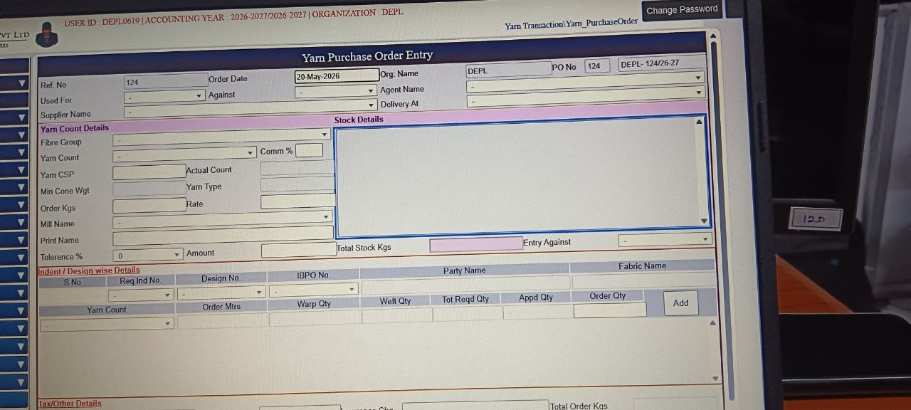
Yarn Purchase Order Entry
Purpose
- Procurement management: Record and track yarn purchase orders with supplier and agent details.
- Inventory control: Monitor yarn stock levels and ensure availability for production.
- Cost management: Capture rates, amounts, and tax details for accurate financial tracking.
- Production linkage: Connect yarn orders to specific designs, buyer orders, and fabric requirements.
- Compliance: Maintain proper documentation for GST, commissions, and supplier contracts.

Main Functions
- Purchase order creation: Generate and record new yarn purchase orders with supplier, agent, and delivery details.
- Yarn specification management: Define fibre group, yarn count, CSP, type, cone weight, tolerance %, and order quantity.
- Stock monitoring: Track total stock in kilograms and update inventory records.
- Indent/design linkage: Associate yarn orders with requisition numbers, design numbers, buyer orders, and fabric names.
- Quantity allocation: Manage warp and weft quantities, required vs approved quantities, and final order quantities.
- Financial tracking: Record rates, amounts, and tax details for accounting integration.
- Supplier coordination: Maintain supplier and mill details for procurement and delivery management.
Order Information

Field Name | Field Type | What Data Should Be Added / Where It Connects
Ref No | Numeric | Auto-generated reference number
Order Date | Date Picker | Purchase order date
Org. Name | Dropdown | Organization list (Org Master)
PO No | Numeric | Purchase order number
DEPL-124/26-27 | Text | Internal PO reference
Used For | Text | Usage purpose
Against | Dropdown | Against reference
Agent Name | Dropdown | Agent list (Agent Master)
Supplier Name | Dropdown | Supplier list (Supplier Master)
Delivery At | Dropdown | Delivery location (Delivery Place Master)
Yarn Count Details
Field Name | Field Type | What Data Should Be Added / Where It Connects
Supplier Name | Dropdown | Supplier list (Supplier Master)
Fibre Group | Dropdown | Fibre group classification (Fibre Group Master)
Yarn Count | Dropdown | Yarn count values (Yarn Count Master)
Yarn CSP | Numeric | Yarn CSP value
Min Cone Wgt | Numeric | Minimum cone weight
Order Kgs | Numeric | Order quantity in kilograms
Mill Name | Dropdown | Mill list (Mill Master)
Print Name | Text | Print name reference
Tolerance % | Numeric | Tolerance percentage
Indent / Design Wise Details

Field Name | Field Type | What Data Should Be Added / Where It Connects
S No | Auto | Serial number
Req Ind No | Dropdown | Indent reference
Design No | Dropdown | Design reference
IBPO No | Dropdown | Internal Buyer PO reference (Buyer PO Master)
Party Name | Text | Party list (Party Master)
Fabric Name | Text | Fabric list (Fabric Master)
Yarn Count | Dropdown | Yarn count values (Yarn Count Master)
Order Mtrs | Numeric | Order quantity in meters
Warp Qty | Numeric | Warp quantity
Weft Qty | Numeric | Weft quantity
Tot Reqd Qty | Numeric | Total required quantity
Appd Qty | Numeric | Approved quantity
Order Qty | Numeric | Order quantity
Add Button | Action | Add row to table
Tax / Other Details
Field Name | Field Type | What Data Should Be Added / Where It Connects
Freight | Dropdown | Freight charges
Freight Chg | Numeric | Freight charge amount
Insurance Chg | Numeric | Insurance charge amount
Total Order Kgs | Numeric | Total order quantity in kilograms
Transport | Dropdown | Transporter list (Transport Master)
TAX Type | Dropdown | GST / VAT / Other (Tax Master)
Taxable Amount | Numeric | Taxable value
Date of Dispatch | Date Picker | Dispatch date (e.g., 29-May-2026)
Packing Type | Dropdown | Packing options (Packing Master)
SGST % | Numeric | State GST percentage
CGST % | Numeric | Central GST percentage
IGST % | Numeric | Integrated GST percentage
Labeling | Text | Labeling details
Colour | Dropdown | Standard color list (Color Master)
Nett Amount | Numeric | Net payable amount
Due Days | Numeric | Credit period in days
Remarks | Text | Additional notes
Consolidated Dropdown Fields
Dropdown Field | What Data Should Be Added
Org. Name | Organization list
Against | Against reference
Agent Name | Agent list
Supplier Name | Supplier list
Delivery At | Delivery location
Fibre Group | Fibre group classification
Yarn Count | Yarn count values
Mill Name | Mill list
IBPO No | Internal Buyer PO reference
Req Ind No | Indent reference
Design No | Design reference
Yarn Count (Indent Section) | Yarn count values
Transport | Transporter list
TAX Type | GST / VAT / Other
Packing Type | Packing options
Colour | Standard color list

Consolidated Dropdown Fields – Matched vs Unmatched
Dropdown Field | Match Status | What Data Should Be Added | Where It Connects
Org. Name | ❌ Unmatched | Organization list | Org Master (not visible in screenshots)
Against | ❌ Unmatched | Against reference | No direct Sub Master found
Agent Name | ❌ Unmatched | Agent list | Agent Master (not visible in screenshots)
Supplier Name | ❌ Unmatched | Supplier list | Supplier Master (not visible in screenshots)
Delivery At | ❌ Unmatched | Delivery location | Delivery Place Master (not visible in screenshots)
Fibre Group | ✅ Matched | Fibre group classification | Fibre Count Master (visible in screenshots)
Yarn Count | ✅ Matched | Yarn count values | Yarn Count Master
Mill Name | ✅ Matched | Mill list | Mill Name Master
IBPO No | ❌ Unmatched | Internal Buyer PO reference | Buyer PO Master (not visible in screenshots)
Req Ind No | ❌ Unmatched | Indent reference | Indent Master (not visible in screenshots)
Design No | ✅ Matched | Design reference | Design Type / Design Color (Sub Master options visible)
Yarn Count (Indent Section) | ✅ Matched | Yarn count values | Yarn Count Master
Transport | ❌ Unmatched | Transporter list | Transport Master (not visible in screenshots)
TAX Type | ❌ Unmatched | GST / VAT / Other | Tax Master (not visible in screenshots)
Packing Type | ✅ Matched | Packing options | Bale Type / Packing Master (visible under Sub Masters)
Colour | ✅ Matched | Standard color list | Color Master

Yarn Purchase-Inward Entry

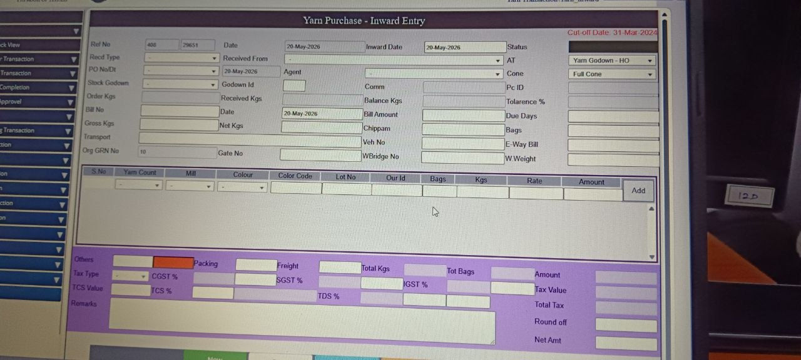
Purpose
- Goods receipt management: Record details of yarn received against purchase orders.
- Inventory update: Update stock godown records with received quantities and lot details.
- Financial compliance: Capture bill numbers, amounts, taxes (GST, TCS, TDS), and ensure accounting accuracy.
- Quality and tolerance tracking: Monitor received vs ordered quantities, cone weights, and tolerance percentages.
- Logistics documentation: Record transport details, vehicle numbers, e-way bills, and weighbridge data.

Main Functions
- Inward entry creation: Generate inward records with reference numbers, dates, and supplier/agent details.
- Purchase order linkage: Match received yarn against purchase orders for reconciliation.
- Stock management: Update godown stock with received kgs, bags, and lot numbers.
- Tax and billing integration: Record bill details, apply GST/CGST/SGST, TCS, and TDS for compliance.
- Logistics tracking: Capture transport mode, vehicle details, gate entry, weighbridge numbers, and e-way bill references.
- Variance control: Compare ordered vs received quantities, track balance kgs, and tolerance levels.
- Audit trail: Maintain complete records for inspection, reconciliation, and compliance audits.

Inward Entry – General Information

Field Name | Field Type | What Data Should Be Added / Where It Connects
Ref No | Numeric | Auto-generated reference number
Date | Date Picker | Entry date
Inward Date | Date Picker | Inward entry date
Status | Text | Status code (e.g., AT)
Recvd Type | Dropdown | Received type (Direct / Against PO)
Received From | Dropdown | Supplier / Party list (Supplier Master / Party Master)
PO No / Dt | Dropdown+ Date | Purchase order number and date
Agent | Dropdown | Agent list (Agent Master)
Stock Godown | Dropdown | Godown list (Godown Master)
Godown Id | Numeric | Godown identifier
Cone | Dropdown | Cone type (Full Cone / Half Cone)
Order Kgs | Numeric | Ordered kilograms
Received Kgs | Numeric | Received kilograms
Balance Kgs | Numeric | Balance kilograms
Pc ID | Text | Process ID
Tolerance % | Numeric | Tolerance percentage
Bill No | Text | Bill reference
Bill Amount | Numeric | Bill value
Gross Kgs | Numeric | Gross kilograms
Net Kgs | Numeric | Net kilograms
Chipnam | Text | Chip name reference
Due Days | Numeric | Credit period in days
Transport | Text | Transporter list (Transport Master)
Veh No | Text | Vehicle registration
Bags | Numeric | Bag count
E-Way Bill | Text | E-way bill reference
Org GRN No | Numeric | Goods Receipt Note number
Gate No | Numeric | Gate reference
WBridge No | Text | Weighbridge reference
W Weight | Numeric | Weighbridge weight
Yarn Details Section
Field Name | Field Type | What Data Should Be Added / Where It Connects
S No | Auto | Serial number
Yarn Count | Dropdown | Yarn count values (Yarn Count Master)
Mill | Dropdown | Mill list (Mill Name Master)
Colour | Dropdown | Standard color list (Color Master)
Color Code | Text | Internal color code
Lot No | Text | Lot reference
Our Id | Text | Internal identifier
Bags | Numeric | Bag count
Kgs | Numeric | Kilograms
Rate | Numeric | Rate per kg
Amount | Numeric | Amount
Add Button | Action | Add row to table

Tax / Other Details Section
Field Name | Field Type | What Data Should Be Added / Where It Connects
Others | Text | Other remarks
Packing | Dropdown | Packing options (Packing Master)
Freight | Numeric | Freight charges
Total Kgs | Numeric | Total kilograms
Tot Bags | Numeric | Total bags
Amount | Numeric | Amount
Tax Type | Dropdown | GST / VAT / Other (Tax Master)
CGST % | Numeric | Central GST percentage
SGST % | Numeric | State GST percentage
IGST % | Numeric | Integrated GST percentage
Tax Value | Numeric | Taxable value
TCS Value | Numeric | Tax Collected at Source
TDS % | Numeric | Tax Deducted at Source
Total Tax | Numeric | Total tax
Round Off | Numeric | Round-off adjustment
Net Amt | Numeric | Net payable amount
Remarks | Text | Additional notes
Consolidated Dropdown Fields
Dropdown Field | What Data Should Be Added | Where It Connects
Recvd Type | Received type (Direct / Against PO) | Sub Master (Received Type)
Received From | Supplier / Party list | Supplier Master / Party Master
PO No / Dt | Purchase order number and date | Buyer PO Master
Agent | Agent list | Agent Master
Stock Godown | Godown list | Godown Master
Cone | Cone type (Full Cone / Half Cone) | Cone Master
Yarn Count | Yarn count values | Yarn Count Master
Mill | Mill list | Mill Name Master
Colour | Standard color list | Color Master
Packing | Packing options | Packing Master
Tax Type | GST / VAT / Other | Tax Master
Dropdown Fields – Matched vs Unmatched
Dropdown Field | Match Status | What Data Should Be Added | Where It Connects
Recvd Type | ❌ Unmatched | Received type (Direct / Against PO) | No Sub Master visible
Received From | ❌ Unmatched | Supplier / Party list | Supplier Master / Party Master (not visible)
PO No / Dt | ❌ Unmatched | Purchase order reference | Buyer PO Master (not visible)
Agent | ❌ Unmatched | Agent list | Agent Master (not visible)
Stock Godown | ✅ Matched | Godown list | Godown Master
Cone | ❌ Unmatched | Cone type (Full Cone / Half Cone) | Not found in Sub Masters
Yarn Count | ✅ Matched | Yarn count values | Yarn Count Master
Mill | ✅ Matched | Mill list | Mill Name Master
Colour | ✅ Matched | Standard color list | Color Master
Packing | ✅ Matched | Packing options | Packing Master / Bale Type
Tax Type | ❌ Unmatched | GST / VAT / Other | Tax Master (not visible)

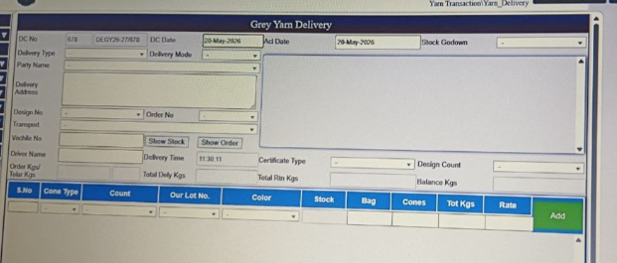

Grey Yarn Delivery

Purpose
- Delivery management: Record and track yarn deliveries to customers, agents, or internal units.
- Inventory reconciliation: Deduct delivered quantities from stock and update balance.
- Order fulfillment: Link deliveries to buyer orders and design numbers for traceability.
- Logistics documentation: Capture transport, vehicle, and delivery address details.
- Financial compliance: Record delivery challans (DC), rates, and amounts for billing and audit.

Main Functions
- Delivery challan creation: Generate DC numbers and dates for each yarn dispatch.
- Order linkage: Connect deliveries to order numbers, design numbers, and party names.
- Stock update: Show available stock, deduct delivered kgs, and track balance quantities.
- Logistics tracking: Record transport mode, vehicle number, and delivery address.
- Return management: Track total delivered kgs, returned kgs, and balance kgs.
- Rate and amount calculation: Apply rates to delivered quantities for financial records.
- Certification & compliance: Capture certificate type and delivery acknowledgments for audit purposes.

Delivery Information
Field Name | Field Type | What Data Should Be Added / Where It Connects
DC No | Numeric | Delivery challan number
DC Date | Date Picker | Delivery challan date
Ref Date | Date Picker | Reference date
Stock | Dropdown | Godown list (Godown Master)
Delivery Type | Dropdown | Delivery type (Direct / Against Order)
Party Name | Dropdown | Party list (Party Master)
Delivery Mode | Dropdown | Mode of delivery (By Road / By Rail / Courier)
Delivery Address | Text | Address details
Design No | Dropdown | Design reference (Design Master)
Order No | Dropdown | Order reference (Buyer Order Master)
Transport | Dropdown | Transporter list (Transport Master)
Vehicle No | Text | Vehicle registration
Delivery Name | Text | Person receiving delivery
Delivery Time | Time Picker | Delivery time
Certificate Type | Dropdown | Certificate type (Certified Type Sub Master)
Design Count | Dropdown | Design count
Order Kgs / Total Kgs | Numeric | Ordered kilograms
Total Dely Kgs | Numeric | Delivered kilograms
Total Rtn Kgs | Numeric | Returned kilograms
Balance Kgs | Numeric | Balance kilograms

Yarn Delivery Table
Field Name | Field Type | What Data Should Be Added / Where It Connects
S No | Auto | Serial number
Cone Type | Dropdown | Cone type (Full / Half Cone)
Count | Dropdown | Yarn count values (Yarn Count Master)
Our Lot No | Dropdown | Lot reference
Color | Dropdown | Standard color list (Color Master)
Stock | Numeric | Stock quantity
Bag | Numeric | Bag count
Cones | Numeric | Cone count
Tot Kgs | Numeric | Total kilograms
Rate | Numeric | Rate per kg
Add Button | Action | Add row to table
Dropdown Fields
Dropdown Field | What Data Should Be Added
Stock | Godown list
Delivery Type | Delivery type (Direct / Against Order)
Party Name | Party list
Delivery Mode | Mode of delivery (Road / Rail / Courier)
Design No | Design reference
Order No | Order reference
Transport | Transporter list
Certificate Type | Certificate type
Design Count | Design count
Cone Type | Cone type (Full / Half Cone)
Count | Yarn count values
Our Lot No | Lot reference
Color | Standard color list

Dropdown Fields – Matched vs Unmatched
Dropdown Field | Match Status | What Data Should Be Added | Where It Connects
Stock (Godown) | ✅ Matched | Godown list | Seen in ERP menu → Godown Master
Delivery Type | ❌ Unmatched | Delivery type (Direct / Against Order) | Not visible in screenshots
Party Name | ❌ Unmatched | Party list | Party Master (ERP menu, not in E-Way Bill)
Delivery Mode | ❌ Unmatched | Mode of delivery (Road / Rail / Courier) | Not visible in screenshots
Design No | ❌ Unmatched | Design reference | Design Master (ERP menu)
Order No | ❌ Unmatched | Order reference | Order Master (ERP menu)
Transport | ✅ Matched | Transporter list | ERP menu → Transport Master
Certificate Type | ❌ Unmatched | Certificate type | Not visible in screenshots
Design Count | ❌ Unmatched | Design count | Not visible in screenshots
Cone Type | ❌ Unmatched | Cone type (Full / Half Cone) | Not visible in screenshots
Count (Yarn Count) | ✅ Matched | Yarn count values | ERP menu → Yarn Count Master
Our Lot No | ❌ Unmatched | Lot reference | Lot Master (ERP menu, not in E-Way Bill)
Color | ✅ Matched | Standard color list | ERP menu → Color Master

EWAY BILL ENTRY
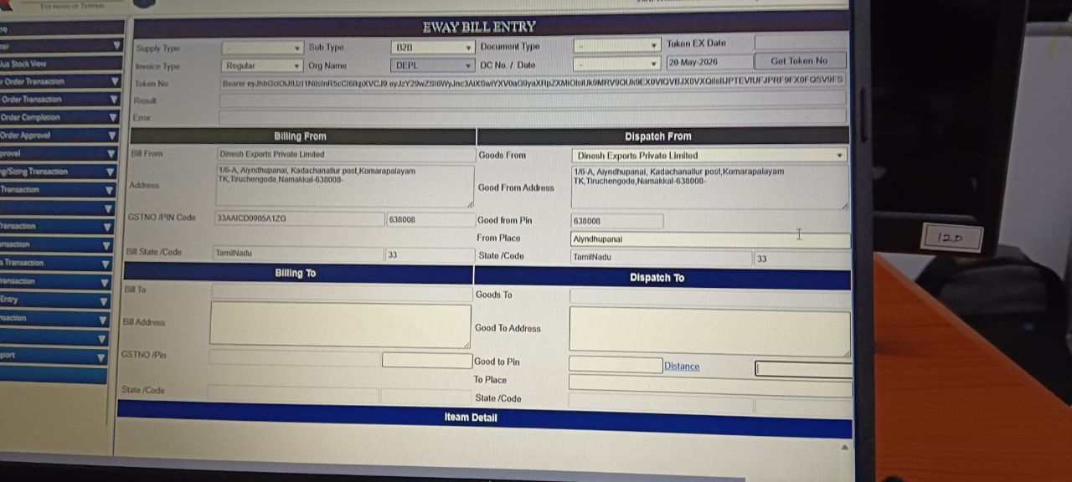
Purpose
- Legal compliance: Ensure goods movement follows GST rules by generating valid e-way bills.
- Logistics documentation: Record dispatch and delivery details for transport tracking.
- Billing integration: Link billing and dispatch addresses with GST numbers for accuracy.
- Audit trail: Maintain digital records of goods movement for inspections and audits.
- Operational efficiency: Streamline the process of generating, storing, and retrieving waybills.

Main Functions
- Bill generation: Create e-way bills with supply type, invoice type, and document type.
- Billing details management: Capture “Billing From” and “Billing To” information including GST numbers and addresses.
- Dispatch details: Record “Dispatch From” and “Dispatch To” addresses, pin codes, and distances.
- Item detail entry: Add product details like quantity, description, and tax values.
- Transport tracking: Integrate transport details such as vehicle numbers and delivery points.
- Token management: Handle authentication tokens for secure bill generation.
- Error handling: Provide fields for results and error messages to ensure smooth processing.
Top Section
Field | Type | Meaning
Supply Type | Dropdown | Outward (sales), Inward (purchase/return), etc.
Sub Type | Dropdown | Transaction category (B2B, B2C, export, import).
Document Type | Dropdown | Supporting document (invoice, delivery challan, bill of entry).
Token Expiry Date | Date picker | Expiration date of authentication token.
Invoice Type | Dropdown | Regular, bill-to-ship-to, or other invoice categories.
Org Name | Text | Name of the organization generating the bill.
DC No./Date | Text + Date | Delivery challan number and date.
Token No | Text (system-generated) | Authentication token string for API access.
Result / Error | Text (system output) | Shows success or error messages after submission.

Billing From Section
Field | Type | Meaning
Bill From | Text | Supplier’s name.
Address | Text | Supplier’s full address.
GSTIN / PIN Code | Text | Supplier’s GST number and postal PIN.
PIN Code | Numeric | Postal PIN code.
Bill State / Code | Dropdown | State name and code (e.g., Tamil Nadu, 33).

Dispatch From Section
Field | Type | Meaning
Goods From | Text | Name of dispatching entity.
Good From Address | Text | Dispatch location address.
Good From Pin | Numeric | Dispatch location PIN code.
From Place | Text | Town/village name.
State / Code | Dropdown | State name and code.

Billing To Section
Field | Type | Meaning
Bill To | Text | Buyer’s name.
Bill Address | Text | Buyer’s full address.
GSTIN / Pin | Text | Buyer’s GST number and postal PIN.
State / Code | Dropdown | Buyer’s state name and code.

Dispatch To Section
Field | Type | Meaning
Goods To | Text | Recipient of goods.
Good To Address | Text | Destination address.
Good To Pin | Numeric | Destination PIN code.
To Place | Text | Town/village name.
State / Code | Dropdown | Destination state name and code.
Distance | Numeric | Distance in kilometers between source and destination.

Item Details Section
Field | Type | Meaning
Item Description | Text | Product name/description.
HSN Code | Text | Harmonized System of Nomenclature code for goods.
Quantity | Numeric | Number of units.
Unit | Dropdown | Unit of measurement (kg, pcs, etc.).
Value | Numeric | Taxable value of goods.
Tax Details | Numeric | CGST, SGST, IGST, Cess amounts.
Consolidated Dropdown Fields
Dropdown Field | What Data Should Be Added
Supply Type | Outward (sales), Inward (purchase/return), etc.
Sub Type | Transaction category (B2B, B2C, export, import).
Document Type | Supporting document (invoice, delivery challan, bill of entry).
Invoice Type | Regular, bill-to-ship-to, or other invoice categories.
Bill State / Code | Supplier’s state name and code (e.g., Tamil Nadu, 33).
State / Code (Dispatch From) | Dispatch location state name and code.
State / Code (Billing To) | Buyer’s state name and code.
State / Code (Dispatch To) | Destination state name and code.
Unit | Unit of measurement (kg, pcs, etc.).

Dropdown Fields – Matched vs Unmatched (from screenshots)
Dropdown Field | Match Status | What Data Should Be Added | Where It Connects in Form
Supply Type | ✅ Matched | Outward (sales), Inward (purchase/return), etc. | Top section
Sub Type | ✅ Matched | Transaction category (B2B, B2C, export, import). | Top section
Document Type | ✅ Matched | Supporting document (invoice, delivery challan, bill of entry). | Top section
Invoice Type | ✅ Matched | Regular, bill-to-ship-to, or other invoice categories. | Top section
Bill State / Code | ✅ Matched | Supplier’s state name and code (e.g., Tamil Nadu, 33). | Billing From section
State / Code (Dispatch From) | ✅ Matched | Dispatch location state name and code. | Dispatch From section
State / Code (Billing To) | ✅ Matched | Buyer’s state name and code. | Billing To section
State / Code (Dispatch To) | ✅ Matched | Destination state name and code. | Dispatch To section
Unit | ✅ Matched | Unit of measurement (kg, pcs, etc.). | Item Details section
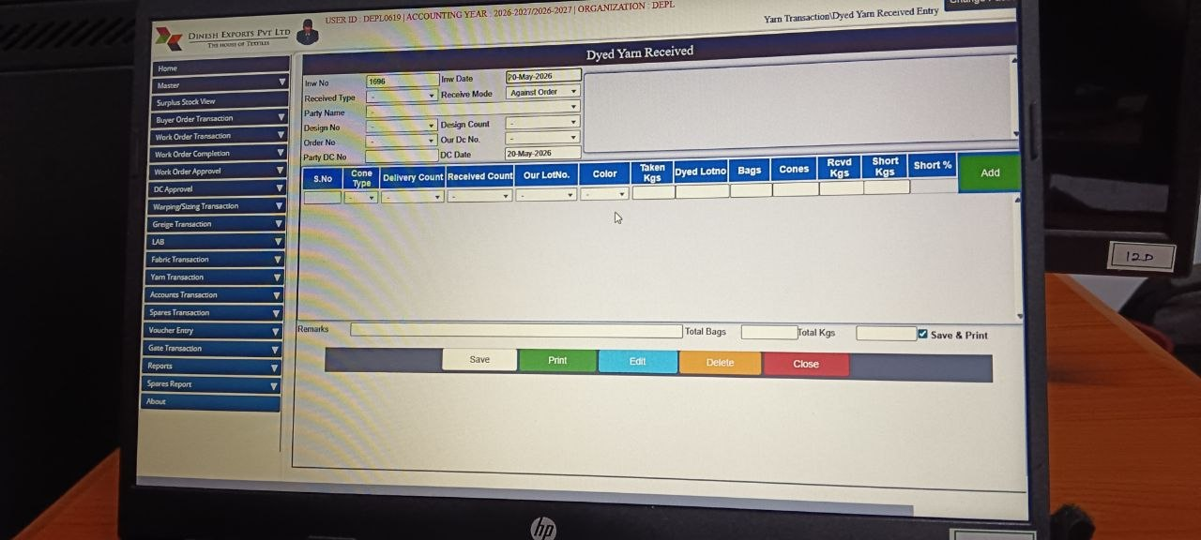
Dyed Yarn Received

Purpose
- Inventory update: Record dyed yarn quantities received and update stock levels.
- Order reconciliation: Match received yarn against buyer orders, design numbers, and delivery challans.
- Quality control: Track short kgs, short %, and ensure received counts match delivery counts.
- Logistics documentation: Record party DC numbers, our DC numbers, and delivery details.
- Financial compliance: Maintain invoice numbers, dates, and quantities for billing and audit purposes.

Main Functions
- Receipt entry: Create records for each dyed yarn consignment with invoice and DC details.
- Order linkage: Connect received yarn to specific orders, design numbers, and counts.
- Stock update: Record received kgs, bags, cones, and update warehouse inventory.
- Variance tracking: Compare delivery count vs received count, track shortages, and calculate short %.
- Lot management: Record dyed lot numbers and link them to our lot references for traceability.
- Reporting & documentation: Generate reports, print receipts, and maintain audit trails.
- Remarks & communication: Capture remarks and notes for internal coordination.

Top Section Fields
Field | Type | Meaning
Inv No | Text (numeric) | Invoice number for the transaction.
Inv Date | Date picker | Date of the invoice.
Received Type | Dropdown | Type of receipt (Direct / Against Order).
Receive Mode | Dropdown | Mode of receipt (e.g., Against Order, Direct).
Party Name | Dropdown | Supplier or party delivering the goods.
Design No | Dropdown | Design reference linked to the order.
Design Count | Dropdown | Count of design (pattern reference).
Order No | Dropdown | Order reference number.
Our Dc No. | Dropdown | Internal delivery challan reference.
Party DC No | Dropdown | Supplier’s delivery challan reference.
DC Date | Date picker | Date of delivery challan.
Table Section Fields
Field | Type | Meaning
S.No | Numeric (auto) | Serial number for each entry row.
Cone Type | Dropdown | Type of cone (Full / Half).
Delivery Count | Numeric | Quantity count delivered.
Received Count | Numeric | Quantity count received.
Our Lot No. | Dropdown | Internal lot reference number.
Color | Dropdown | Standard color list for yarn.
Taken Kgs | Numeric | Weight taken in kilograms.
Dyed Lot No. | Text | Lot number of dyed yarn batch.
Bags | Numeric | Number of bags received.
Cones | Numeric | Number of cones received.
Rcvd Kgs | Numeric | Actual weight received in kilograms.
Short Kgs | Numeric | Shortage in kilograms compared to expected.
Short % | Numeric | Percentage of shortage.
Consolidated Dropdown Fields
Dropdown Field | What Data Should Be Added | Where It Connects
Received Type | Type of receipt (Direct / Against Order). | Top section
Receive Mode | Mode of receipt (Against Order, Direct, Road, Rail, Courier). | Top section
Party Name | Supplier or party delivering the goods. | Top section
Design No | Design reference linked to the order. | Top section
Design Count | Count of design (pattern reference). | Top section
Order No | Order reference number. | Top section
Our Dc No | Internal delivery challan reference. | Top section
Party DC No | Supplier’s delivery challan reference. | Top section
Cone Type | Type of cone (Full / Half). | Table section
Our Lot No | Internal lot reference number. | Table section
Color | Standard color list for yarn. | Table section
Consolidated Dropdown Fields – Matched vs Unmatched
Dropdown Field | Match Status | What Data Should Be Added | ERP Module Connection
Received Type | ✅ Matched | Type of receipt (Direct / Against Order). | Sub Master (Receive Type)
Receive Mode | ✅ Matched | Mode of receipt (Against Order, Direct, Road, Rail, Courier). | Sub Master (Delivery Mode)
Party Name | ✅ Matched | Supplier or party delivering the goods. | Party Master / Party Type
Design No | ✅ Matched | Design reference linked to the order. | Design Master
Design Count | ✅ Matched | Count of design (pattern reference). | Design Master (Count System)
Order No | ✅ Matched | Order reference number. | Buyer Order / Order Type Master
Our Dc No | ✅ Matched | Internal delivery challan reference. | Delivery Challan Master
Party DC No | ✅ Matched | Supplier’s delivery challan reference. | Party Master (DC Reference)
Cone Type | ✅ Matched | Type of cone (Full / Half). | Sub Master (Cone Type)
Our Lot No | ✅ Matched | Internal lot reference number. | Lot Master
Color | ✅ Matched | Standard color list for yarn. | Color Master

Dyed Yarn Delivery
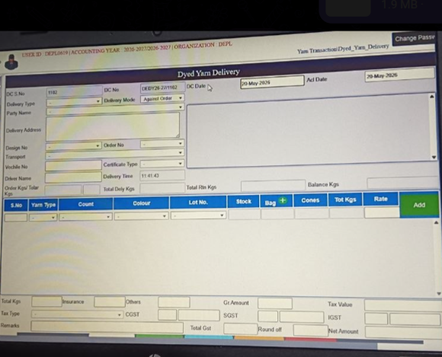

Purpose
- Delivery management: Record dyed yarn dispatches with challan numbers, dates, and delivery details.
- Order fulfillment: Link deliveries to buyer orders, design numbers, and party names for traceability.
- Inventory reconciliation: Deduct delivered quantities from stock and update balance kgs.
- Financial compliance: Capture rates, amounts, and GST/IGST/SGST for billing and audit.
- Logistics documentation: Record transport, driver, and delivery address details for smooth dispatch.

Main Functions
- Delivery challan creation: Generate DC numbers and dates for each dyed yarn dispatch.
- Order linkage: Connect deliveries to order numbers, design numbers, and certificate types.
- Stock update: Show available stock, deduct delivered kgs, and track balance quantities.
- Logistics tracking: Record transport mode, driver name, and delivery address.
- Return management: Track total delivered kgs, returned kgs, and balance kgs.
- Rate and tax calculation: Apply rates, insurance, and taxes (SGST, IGST, GST) to calculate net amounts.
- Audit trail: Maintain complete records for inspection, reconciliation, and compliance audits.

Top Section Fields
Field | Type | Meaning
DC No | Text (numeric) | Delivery challan number (system-generated).
DC No (second field) | Text | Alternate/internal DC reference (e.g., DEPLY26/277/02).
DC Date | Date picker | Date of the delivery challan.
Add Date | Date picker | Date when the entry was added.
Delivery Type | Dropdown | Type of delivery (Direct / Against Order).
Delivery Mode | Dropdown | Mode of delivery (Road / Rail / Courier / Against Order).
Party Name | Dropdown | Buyer or supplier receiving the yarn.
Delivery Address | Text | Address of the delivery destination.
Design No | Dropdown | Design reference linked to the order.
Order No | Dropdown | Order reference number.
Design Type | Dropdown | Type of design (pattern classification).
Transport | Dropdown | Transporter details (linked to Transport Master).
Certificate Type | Dropdown | Certificate type (e.g., quality, compliance).
Driver Name | Text | Name of the driver handling delivery.
Delivery Time | Time field | Time of delivery entry.
Total Delv Kgs | Numeric | Total kilograms delivered.
Total Rin Kgs | Numeric | Total kilograms returned inward.
Balance Kgs | Numeric | Balance kilograms after delivery/return.

Table Section Fields
Field | Type | Meaning
S.No | Numeric (auto) | Serial number for each row.
Yarn Type | Dropdown | Type of yarn (linked to Yarn Type Master).
Count | Dropdown | Yarn count values (linked to Yarn Count Master).
Colour | Dropdown | Yarn colour (linked to Color Master).
Lot No. | Dropdown | Lot reference number (Lot Master).
Stock | Dropdown | Godown/stock location (Godown Master).
Bag | Numeric | Number of bags delivered.
Cones | Numeric | Number of cones delivered.
Tot Kgs | Numeric | Total kilograms delivered.
Rate | Numeric | Rate per kilogram.
Add | Action | Add row to table.

Bottom Section (Financials)
Field | Type | Meaning
Total Kgs | Numeric | Total weight delivered.
Insurance | Numeric | Insurance charges.
Others | Numeric | Other charges.
COST | Numeric | Cost before tax.
Gr.Amount | Numeric | Gross amount.
SGST | Numeric | State GST.
IGST | Numeric | Integrated GST.
Tax Value | Numeric | Taxable value.
Remarks | Text | Notes or comments.
Total GST | Numeric | Total GST applied.
Round off | Numeric | Rounded adjustment.
Net Amount | Numeric | Final payable amount.
Dropdown Fields & What Data Should Be Added
Dropdown Field | What Data Should Be Added
Delivery Type | Type of delivery (Direct / Against Order).
Delivery Mode | Mode of delivery (Road / Rail / Courier / Against Order).
Party Name | Buyer or supplier receiving the yarn.
Design No | Design reference linked to the order.
Order No | Order reference number.
Design Type | Type of design (pattern classification).
Transport | Transporter details (linked to Transport Master).
Certificate Type | Certificate type (e.g., quality, compliance).
Yarn Type | Type of yarn (linked to Yarn Type Master).
Count | Yarn count values (linked to Yarn Count Master).
Colour | Yarn colour (linked to Color Master).
Lot No | Lot reference number (Lot Master).
Stock | Godown/stock location (Godown Master).
Dropdown Fields – Matched vs Unmatched
Dropdown Field | Match Status | What Data Should Be Added
Delivery Type | ✅ Matched | Type of delivery (Direct / Against Order).
Delivery Mode | ✅ Matched | Mode of delivery (Road / Rail / Courier / Against Order).
Party Name | ✅ Matched | Buyer or supplier receiving the yarn.
Design No | ✅ Matched | Design reference linked to the order.
Order No | ✅ Matched | Order reference number.
Design Type | ✅ Matched | Type of design (pattern classification).
Transport | ✅ Matched | Transporter details (linked to Transport Master).
Certificate Type | ✅ Matched | Certificate type (e.g., quality, compliance).
Yarn Type | ✅ Matched | Type of yarn (linked to Yarn Type Master).
Count | ✅ Matched | Yarn count values (linked to Yarn Count Master).
Colour | ✅ Matched | Yarn colour (linked to Color Master).
Lot No | ✅ Matched | Lot reference number (Lot Master).
Stock | ✅ Matched | Godown/stock location (Godown Master).
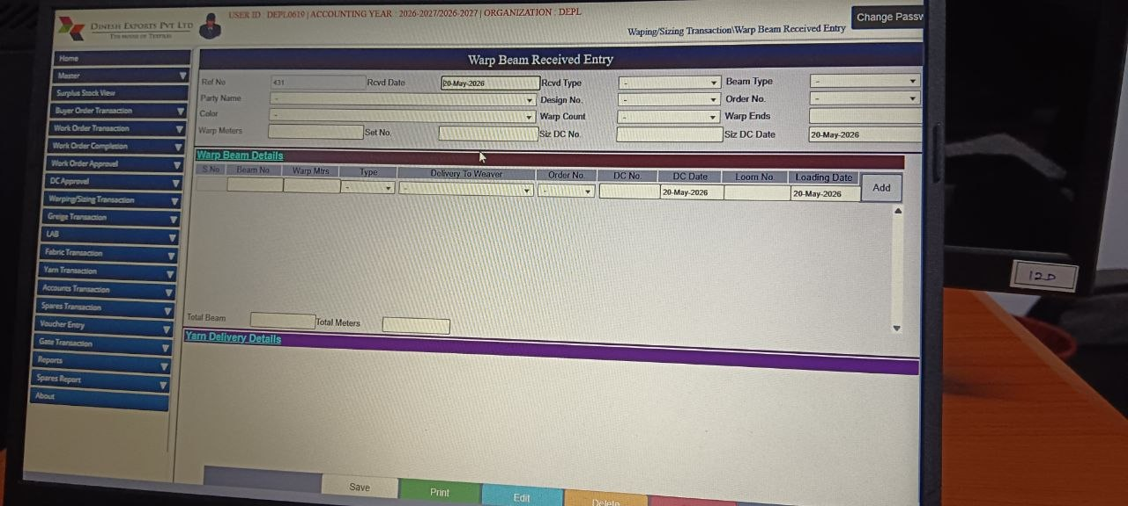

Purpose
- Inventory management: Update stock records when warp beams are received.
- Production linkage: Connect warp beams to specific orders, designs, and looms.
- Process tracking: Monitor warping and sizing activities for production planning.
- Logistics documentation: Record delivery challan details, beam numbers, and loading dates.
- Quality assurance: Ensure warp counts, ends, and meters match order requirements.

Main Functions
- Receipt entry: Create records for warp beams received with reference numbers and dates.
- Beam details management: Track beam numbers, warp meters, types, and delivery to weavers.
- Order linkage: Associate beams with design numbers, order numbers, and DC details.
- Loom allocation: Assign beams to specific looms and record loading dates.
- Stock reconciliation: Update yarn delivery details and balance stock.
- Documentation & reporting: Generate printouts, maintain audit trails, and support production reports.

Top Section Fields
Field | Type | Meaning
Ref No | Text (numeric) | Internal reference number for the entry.
Rcvd Date | Date picker | Date of receipt entry.
Rcvd Type | Dropdown | Type of receipt (e.g., Direct, Against Order).
Beam Type | Dropdown | Type of beam (linked to Beam Master).
Party Name | Dropdown | Supplier or party delivering the warp beam.
Design No | Dropdown | Design reference linked to the order.
Order No | Dropdown | Order reference number.
Color | Dropdown | Warp beam color (linked to Color Master).
Warp Count | Dropdown | Yarn count used in warp (linked to Yarn Count Master).
Warp Ends | Numeric | Number of warp ends.
Warp Meters | Numeric | Length of warp in meters.
Set No | Text | Set number for warp beam batch.
Siz DC No | Dropdown | Sizing delivery challan reference.
Siz DC Date | Date picker | Date of sizing delivery challan.
Warp Beam Details Section (Table)
Field | Type | Meaning
Beam No | Text | Beam identification number.
Warp Mtrs | Numeric | Length of warp beam in meters.
Type | Dropdown | Beam type classification.
Delivery To Weaver | Dropdown | Weaver/party receiving the beam.
Order No | Dropdown | Order reference number.
DC No | Dropdown | Delivery challan reference.
DC Date | Date picker | Date of delivery challan.
Loom No | Dropdown | Loom machine number (linked to Loom Master).
Loading Date | Date picker | Date when beam was loaded.
Total Meters | Numeric | Total meters calculated.
Add | Action | Add row to table.
Dropdown Fields (Top Section + Warp Beam Details)
Dropdown Field | What Data Should Be Added
Rcvd Type | Type of receipt (e.g., Direct, Against Order).
Beam Type | Type of beam (linked to Beam Master).
Party Name | Supplier or party delivering the warp beam.
Design No | Design reference linked to the order.
Order No | Order reference number.
Color | Warp beam color (linked to Color Master).
Warp Count | Yarn count used in warp (linked to Yarn Count Master).
Siz DC No | Sizing delivery challan reference.
Type | Beam type classification (in Warp Beam Details table).
Delivery To Weaver | Weaver/party receiving the beam.
Order No | Order reference number (in Warp Beam Details table).
DC No | Delivery challan reference.
Loom No | Loom machine number (linked to Loom Master).
Dropdown Fields – Matched vs Unmatched
Dropdown Field | Match Status | What Data Should Be Added
Rcvd Type | ✅ Matched | Type of receipt (e.g., Direct, Against Order).
Beam Type | ✅ Matched | Type of beam (linked to Beam Master).
Party Name | ✅ Matched | Supplier or party delivering the warp beam.
Design No | ✅ Matched | Design reference linked to the order.
Order No | ✅ Matched | Order reference number.
Color | ✅ Matched | Warp beam color (linked to Color Master).
Warp Count | ✅ Matched | Yarn count used in warp (linked to Yarn Count Master).
Siz DC No | ✅ Matched | Sizing delivery challan reference.
Type | ✅ Matched | Beam type classification (in Warp Beam Details table).
Delivery To Weaver | ✅ Matched | Weaver/party receiving the beam.
Order No | ✅ Matched | Order reference number (in Warp Beam Details table).
DC No | ✅ Matched | Delivery challan reference.
Loom No | ✅ Matched | Loom machine number (linked to Loom Master).

Wrap Delivery Entry :
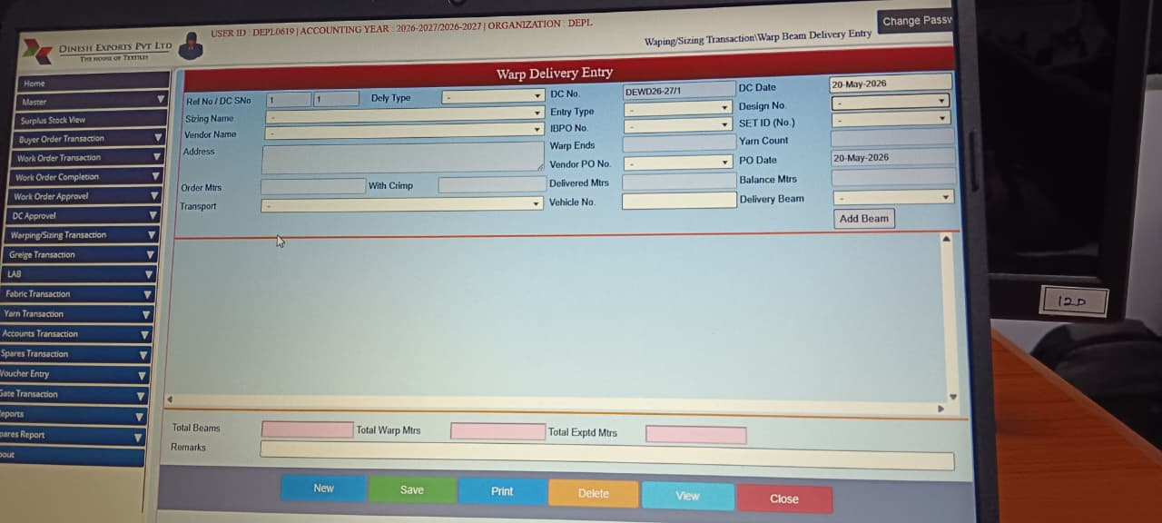

1. Purpose
The Warp Delivery Entry module is designed to manage and track warp beam dispatches from the sizing/warping process to weaving or job-work units. It ensures accurate production movement and logistics tracking.
It helps to:
- Record Warp Beam Dispatch → capture DC number, date, and delivery type.
- Track Beam Quantity & Meters → monitor order meters, delivered meters, and balance meters.
- Link Buyer Order & Design → connect warp beams to specific orders and designs.
- Maintain Vendor/Job Worker Records → store vendor name, PO details, and addresses.
- Monitor Pending vs Delivered → ensure production progress visibility.
- Track Transport & Vehicle → record transport name, vehicle number, and logistics details.

2. Main Functions
Production Movement Tracking — enables the company to record and monitor warp beam transfers between production stages.
Destination Units:
- Weaving Units
- Job Workers
- Processing Vendors
This module records:
- Beam Identification → Ref No, DC No, Set ID, Yarn Count, Warp Ends.
- Recipient Details → Vendor name, PO number, sizing name, address.
- Order & Design Linkage → Buyer order, design number, IBPO reference.
- Delivery Quantity → Delivered meters, balance meters, total beams.
- Transport Tracking → Delivery type, transport details, vehicle number.

3. Fields
Field Name | Purpose | What Should be Added
Ref No / DC SNo | Internal delivery/challan reference number | System/manual delivery reference number
Dely Type | Type of delivery transaction | Select delivery type/category
DC No | Delivery challan number | Enter delivery challan number
DC Date | Delivery date | Select delivery challan date
Sizing Name | Name of sizing unit/job worker | Select sizing unit/job worker name
Vendor Name | Vendor or party receiving material | Select vendor/customer name
Entry Type | Type of entry transaction | Select transaction entry type
BPO No | Buyer purchase/order number | Enter buyer PO/order number
Design No | Fabric design number | Select/enter fabric design number
Address | Vendor/job worker address | Enter vendor/job worker address
SET ID (No.) | Set or beam identification number | Enter set/beam identification number
Warp Ends | Total warp ends count | Enter total warp ends quantity
Yarn Count | Yarn specification/count | Enter yarn count/specification
Vendor PO No | Vendor purchase/work order number | Enter vendor PO/work order number
PO Date | Purchase order date | Select purchase order date
Order Mtrs | Ordered fabric meters | Enter ordered meter quantity
With Crimp | Crimp percentage/details | Enter crimp percentage/details
Delivered Mtrs | Delivered meter quantity | Enter delivered quantity
Balance Mtrs | Pending balance quantity | System-calculated balance quantity
Transport | Transport company/method | Select transport/logistics provider
Vehicle No | Vehicle number used for dispatch | Enter vehicle registration number
Delivery Beam | Beam delivery selection/type | Select delivery beam type/details
Add Beam | Button to add beam details | Click to add beam information
Total Beams | Total number of beams | System-calculated total beam quantity
Total Warp Mtrs | Total warp meter quantity | System-calculated warp meters
Total Exptd Mtrs | Expected production meters | System-calculated expected quantity
Remarks | Additional comments/notes | Enter delivery remarks/comments

4. Buttons Function
Button | Purpose | What Should be Added
New | Create new entry | Click to create new delivery entry
Save | Save current transaction | Click to save delivery transaction
Print | Print delivery challan/report | Click to print challan/report
Delete | Remove entry | Click to delete selected entry
View | View saved records | Click to search/view saved entries
Close | Exit screen | Click to close delivery screen
Dyed yarn Received
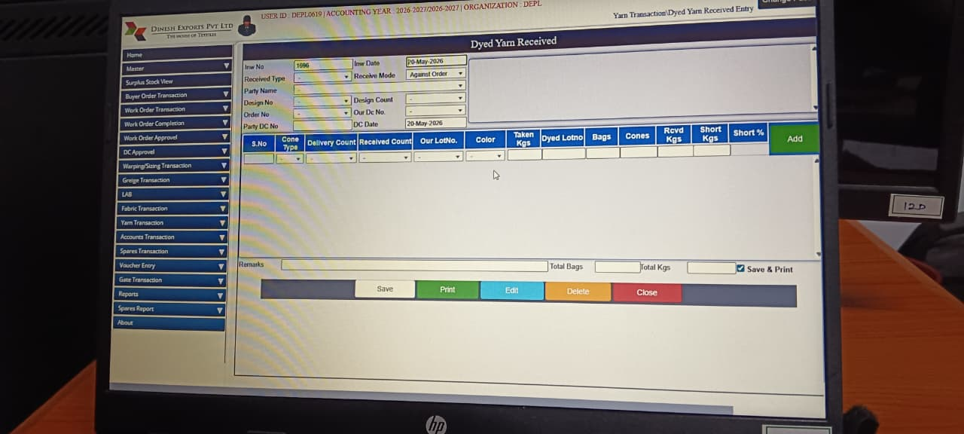

1. Purpose
The Dyed Yarn Received module is used to record and manage the receipt of dyed yarn from vendors or job workers after the dyeing process. It ensures accurate tracking of yarn batches, quantities, and quality for production continuity.
It helps to:
- Record Dyed Yarn Receipts → capture invoice number, DC details, and receipt type.
- Track Yarn Quantities → monitor received kgs, short kgs, and balance.
- Link Orders & Designs → connect dyed yarn to buyer orders and design numbers.
- Maintain Vendor Records → store party name, PO details, and DC references.
- Monitor Quality & Shortages → track cone type, color, and short percentage.
- Support Logistics → record delivery mode, transport details, and remarks.

2. Main Functions
Production Material Tracking — enables the company to record dyed yarn inflow and link it to production stages.
This module records:
- Batch Identification → Dyed lot number, cone type, delivery count.
- Order & Design Linkage → Buyer order, design number, and party DC details.
- Quantity Management → Received kgs, short kgs, short %, total bags, and cones.
- Vendor & Party Details → Party name, invoice number, PO references.
- Quality & Color Tracking → Color shade, cone type, and inspection remarks.
- Logistics Integration → Receive mode, transport details, and delivery challan linkage.

3. Field
Field Name | Purpose | What Should be Added
Inv No | Inward receipt entry number | System/manual inward receipt number
Inv Date | Date of receipt entry | Select inward receipt date
Received Type | Type of yarn receipt | Select receipt type such as Dyed Yarn, Return, Purchase
Receive Mode | Receipt mode/details | Select receipt mode/category
Party Name | Dyeing vendor/job worker name | Select dyeing vendor/job worker
Design No | Related fabric/design number | Enter/select related design number
Design Count | Fabric/yarn count specification | Enter yarn/fabric count details
Order No | Buyer/work order number | Enter buyer/work order reference
Out DC No | Outward DC reference number | Enter outward delivery challan number
Party DC No | Vendor delivery challan number | Enter vendor DC number
DC Date | Vendor DC date | Select vendor challan date

4. Grid/Table Field
Field Name | Purpose | What Should be Added
S.No | Serial number | System-generated serial number
Cone Type | Type of yarn cone | Select yarn cone type
Delivery Count | Delivered yarn count | Enter delivered yarn count
Received Count | Received yarn count | Enter received yarn count
Our Lot No. | Internal yarn lot number | Enter internal yarn lot number
Color | Dyed yarn color | Select/enter yarn color
Taken Kgs | Sent yarn quantity in kilograms | Enter sent yarn weight
Dyed Lot No | Vendor dyed lot reference | Enter dyed lot reference number
Bags | Number of bags received | Enter received bag quantity
Cones | Number of cones received | Enter received cone quantity
Rcvd Kgs | Received yarn weight | Enter actual received weight
Short Kgs | Shortage quantity | System/manual shortage quantity
Short % | Shortage percentage | System-calculated shortage percentage
Add | Add row/details into grid | Click to add yarn inward details

5. Bottom Section Fields
Field Name | Purpose | What Should be Added
Remarks | Additional notes/comments | Enter inward remarks/comments
Total Bags | Total received bags | System-calculated total bags
Total Kgs | Total received yarn weight | System-calculated total kilograms
Save & Print | Save entry and print receipt | Click to save and print inward receipt

6. Buttons Function
Button | Purpose | What Should be Added
Save | Save current receipt entry | Click to save yarn inward details
Print | Print inward receipt report | Click to print inward receipt
Edit | Modify existing entry | Click to edit saved records
Delete | Delete selected entry | Click to remove selected record
Close | Exit screen | Click to close inward receipt screen
Cloth vendor/purchase inward Entry
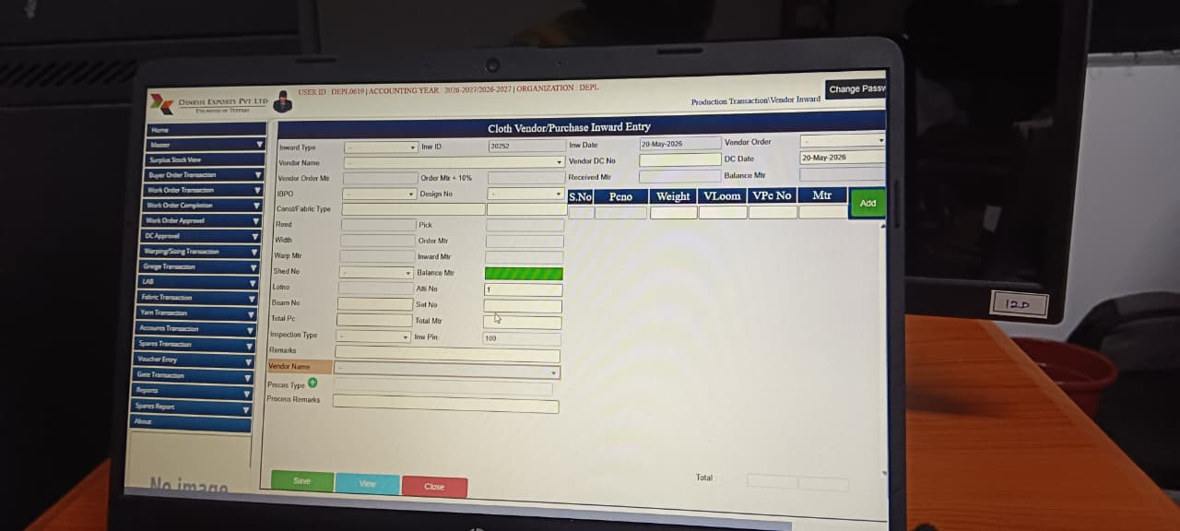
1. Purpose

The Cloth Vendor/Purchase Inward Entry module is designed to manage and record the inward movement of cloth purchased from vendors or received from job workers. It ensures proper tracking of vendor deliveries, inspection, and integration with production and accounts.
It helps to:
- Record Cloth Inward → capture invoice ID, vendor order, and inward meters.
- Track Vendor Deliveries → monitor order meters, inward meters, and balance meters.
- Link Orders & Designs → connect inward cloth to buyer orders and design numbers.
- Maintain Vendor Records → store vendor name, process type, and remarks.
- Support Quality Inspection → inspection type and process remarks ensure QC compliance.
- Enable Logistics Integration → record set numbers, loom details, and transport references.

2. Main Functions
Vendor Purchase Tracking — enables the company to record cloth inward entries and link them to production and accounts.
This module records:
- Invoice & Vendor Details → Invoice ID, vendor name, vendor order.
- Order & Design Linkage → Order meters, design number, set number.
- Quantity Management → Inward meters, balance meters, weight, loom details.
- Inspection & Process Tracking → Inspection type, process type, process remarks.
- Logistics & Storage → VPc No, VLoom, transport references.
- Summary & Reporting → Total inward meters, remarks, and vendor performance reports.

3. Fields
Field Name | Purpose | What Should be Added
Inward Type | Type of inward transaction | Select inward category such as Grey Inward, Process Return, Purchase
Inv ID | Inward entry number | System/manual inward reference number
Inv Dt | Inward entry date | Select inward transaction date
Vendor Order | Vendor/work order reference | Enter vendor/work order number
Vendor Name | Vendor/job worker name | Select vendor or job worker name
Vendor DC No | Vendor delivery challan number | Enter vendor challan number
DC Date | Delivery challan date | Select challan date
Vendor Order Mtr | Ordered meter quantity | Enter vendor ordered quantity
Order Mtr + 10% | Order quantity with allowance | Enter order quantity including allowance
Received Mtr | Received fabric quantity | Enter actual received quantity
Balance Mtr | Pending balance quantity | System-calculated pending quantity
BPO No | Buyer purchase/work order number | Enter buyer PO/work order number
Design No | Fabric design number | Select/enter fabric design number
Party Name | Customer/party name | Select customer/party name
Cloth Article Type | Fabric/article type | Select fabric/article category
Reed | Reed specification | Enter reed specification
Pick | Pick specification | Enter pick specification
Width | Fabric width | Enter fabric width details
Order Mtr | Ordered meters | Enter ordered meter quantity
Warp Mtr | Warp meter quantity | Enter warp quantity
Inward Mtr | Inward received meters | Enter inward received quantity
Shed No | Shed/weaving unit number | Enter/select shed number
Balance Mtr | Remaining pending quantity | System-calculated balance quantity
Looms | Loom machine details | Enter loom/machine details
All No | Allocation/reference number | Enter allocation/reference number
Beam No | Beam identification number | Enter beam number
Set No | Set identification number | Enter set number/reference
Total Mtr | Total meter quantity | System-calculated total meters
Inspection Type | Fabric inspection type | Select inspection category/type
Inv Pin | Inward pin/reference | Enter inward reference PIN
Remarks | Additional comments | Enter remarks/comments
Vendor Name (Bottom) | Additional vendor reference | Select/display vendor details
Process Type | Process category | Select process type
Process Remarks | Process-related comments | Enter process remarks/details

5. Grid/Table Field
Field Name | Purpose | What Should be Added
S.No | Serial number | System-generated serial number
Pcno | Piece number | Enter fabric piece number
Weight | Fabric weight | Enter fabric weight details
VLoom | Loom reference | Enter loom/machine number
VPc No | Vendor piece number | Enter vendor piece reference
Mtr | Meter quantity | Enter received meter quantity
Add | Add row/details into grid | Click to add inward details into grid

6. Buttons Function
Button | Purpose | What Should be Added
Save | Save current inward entry | Click to save inward transaction
View | View saved records | Click to search/view inward entries
Close | Exit screen | Click to close inward screen

ON Table Checking Entry

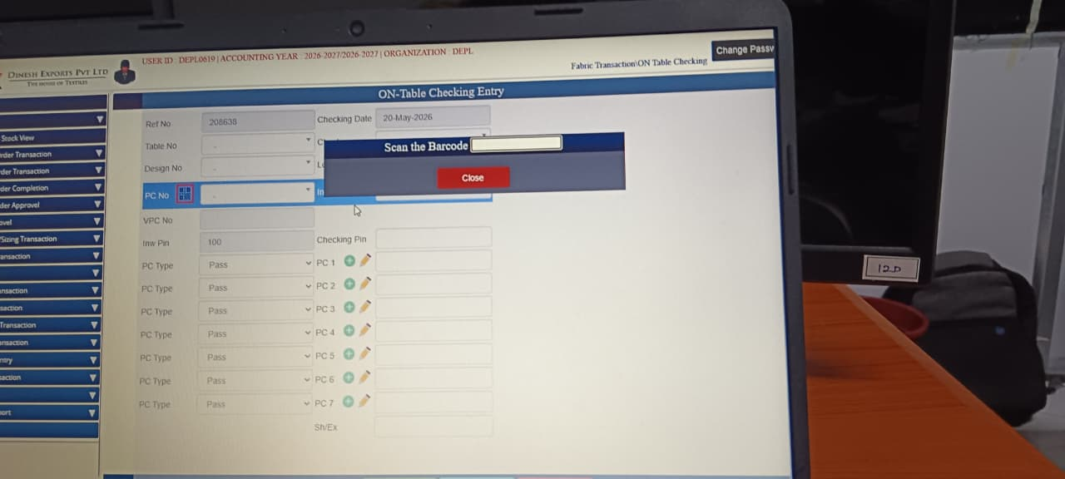

1. Purpose
The On-Table Checking Entry module is used to manage fabric quality inspection at the table level. It ensures that every piece of fabric is scanned, verified, and marked as pass/fail before moving to the next stage.
It helps to:
- Record Fabric Checking → capture reference number, table number, and checking date.
- Scan Barcode for Identification → ensure accurate fabric roll/PC identification.
- Track Design & PC Numbers → link fabric pieces to buyer orders and designs.
- Maintain QC Records → store pass/fail status for each piece checked.
- Monitor Inspection Progress → track number of PCs checked per table.
- Support Quality Compliance → ensure defective pieces are flagged before dispatch.

2. Main Functions
Fabric Quality Control Tracking — enables the company to record inspection results at the table level.
This module records:
- Inspection Identification → Ref No, Checking Date, Table No.
- Design & PC Linkage → Design number, PC number, VPC number.
- Barcode Scanning → scan fabric rolls/pieces for automated entry.
- QC Status → Pass/Fail marking for each PC checked.
- Inspection Records → Checking pins, remarks, and inspection type.
- Reporting & Traceability → generate QC reports for management and link to dispatch.

3. Fields
Field Name | Purpose | What Should be Added
Ref No | Inspection reference number | System/manual inspection reference number
Checking Date | Date of quality inspection | Select inspection/checking date
Table No | Inspection table number | Enter/select inspection table reference
Design No | Fabric design number | Enter/select fabric design number
PC No | Fabric piece number | Enter fabric piece number
VPC No | Vendor piece number | Enter vendor piece reference
Inv Pin | Inward/inspection reference pin | Enter inward inspection PIN/reference
Checking Pin | Checking reference entry | Enter checking/approval reference

4. Barcode Scan Section
Field Name | Purpose | What Should be Added
Scan the Barcode | Scan fabric roll/piece barcode for automatic data loading | Scan barcode using scanner/input barcode number
Close | Close barcode popup window | Click to close barcode scanning window

5. QC/Inspection Fields
Field Name | Purpose | What Should be Added
PC Type | Inspection result status (Pass/Fail/Defect) | Select inspection status such as Pass, Fail, Reject
PC 1 | Inspection point/checking note | Enter inspection observation/details
PC 2 | Inspection point/checking note | Enter inspection observation/details
PC 3 | Inspection point/checking note | Enter inspection observation/details
PC 4 | Inspection point/checking note | Enter inspection observation/details
PC 5 | Inspection point/checking note | Enter inspection observation/details
PC 6 | Inspection point/checking note | Enter inspection observation/details
PC 7 | Inspection point/checking note | Enter inspection observation/details
SWEX | Additional quality remark/reference | Enter special quality remarks/comments

Cloth Delivery Entry
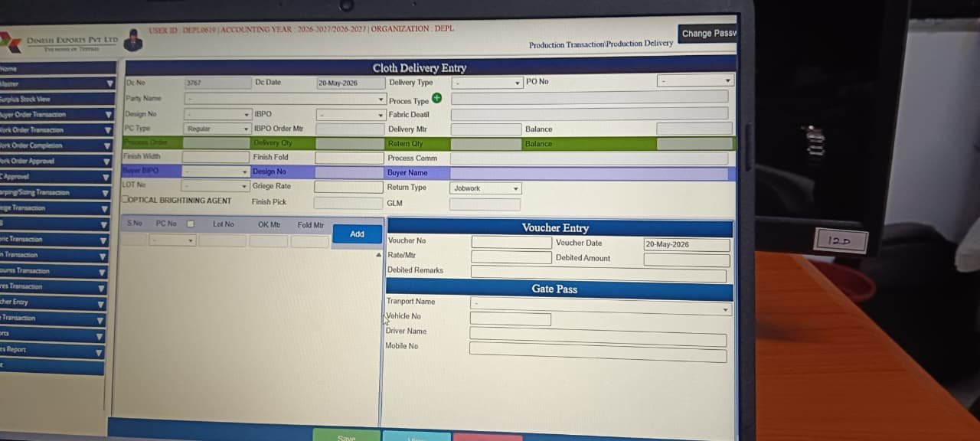

1. Purpose
The Cloth Delivery Entry module is designed to manage and track the delivery of finished or semi-finished cloth from production units or job workers to buyers/vendors. It ensures proper documentation of delivery challans, order linkage, and logistics integration.
It helps to:
- Record Cloth Delivery → capture DC number, date, delivery type, and party details.
- Track Order & Balance → monitor ordered meters, delivered meters, balance, and returns.
- Link Buyer Orders & Designs → connect deliveries to buyer orders, IBPO references, and design numbers.
- Maintain Vendor & Buyer Records → store vendor names, buyer names, and lot details.
- Support Quality & Process Details → record finish width, fold, process comments, and fabric specifications.
- Integrate Financials → voucher entry for rate/meter, debited amount, and remarks.
- Enable Logistics Tracking → transport name, vehicle number, driver details, and gate pass information.

2. Main Functions
Production & Dispatch Tracking — enables the company to record cloth deliveries and integrate them with accounts and logistics.
This module records:
- Delivery Identification → DC number, date, delivery type, PO number.
- Order & Design Linkage → IBPO, design number, lot number, buyer name.
- Quantity Management → delivery quantity, balance meters, return quantity, finish width/fold.
- Process & Fabric Details → process comments, greige rate, optical brightening agent, finish pick.
- Voucher Entry → voucher number, date, rate/meter, debited amount, remarks.
- Gate Pass & Logistics → transport name, vehicle number, driver details, mobile number.
- Reporting & Audit → delivery records, return type, and financial reconciliation.

3. Fields
Field Name | Purpose | What Should be Added
Dc No | Delivery challan number | System/manual delivery challan number
Dc Date | Delivery challan date | Select delivery challan date
Delivery Type | Type of delivery | Select delivery type such as Job Work, Return, Processing
PO No | Purchase/work order number | Enter purchase/work order reference
Party Name | Customer/vendor name | Select customer/vendor name
Process Type | Type of process/job work | Select process type/category
Design No | Fabric design number | Enter/select fabric design number
IBPO | Internal buyer purchase order | Enter/select IBPO reference
Fabric Detail | Fabric specification/details | Enter fabric quality/specification
PC Type | Fabric piece/category type | Select fabric piece type/category
IBPO Order Mtr | Ordered meter quantity | Enter total ordered quantity
Delivery Mtr | Delivered meter quantity | Enter delivery quantity
Balance | Remaining balance quantity | System-calculated balance quantity
Fresh Width | Fabric finished width | Enter finished fabric width
Finish Fold | Fabric folding details | Enter fold type/details
Process Comm | Process comments | Enter process remarks/comments
BPO No | Buyer purchase order number | Enter buyer PO number
Design No (Bottom) | Design reference | Display/select design reference
Buyer Name | Customer/buyer name | Select buyer/customer name
LOT No | Fabric lot number | Enter/select lot number
Griege Rate | Greige fabric rate | Enter greige fabric rate
Return Type | Delivery return type | Select return category/type
Optical Brightening Agent | Chemical/process detail | Enter OBA/process chemical details
Finish Pick | Final fabric pick | Enter finished pick details
GLM | Fabric measurement reference | Enter GLM reference/details

4. Grid/Table Field Explanation
Field Name | Purpose | What Should be Added
S.No | Serial number | System-generated serial number
PC No | Piece number | Enter fabric piece number
Lot No | Lot identification number | Enter/select lot number
OK Mtr | Approved meter quantity | Enter approved quantity
Fold Mtr | Folded meter quantity | Enter folded quantity
Add | Add delivery item to grid | Click to add delivery details into grid

5. Voucher Entry Section
Field Name | Purpose | What Should be Added
Voucher No | Financial voucher reference | Enter accounting voucher number
Voucher Date | Voucher date | Select voucher date
Rate/Mtr | Fabric rate per meter | Enter fabric/process rate
Debited Amount | Delivery/accounting amount | Enter debit/accounting amount
Detailed Remarks | Additional accounting remarks | Enter voucher remarks/comments

6. Gate Pass Section
Field Name | Purpose | What Should be Added
Transport Name | Transport company name | Select transport/logistics company
Vehicle No | Vehicle number | Enter vehicle registration number
Driver Name | Driver details | Enter driver name
Mobile No | Driver mobile number | Enter driver contact number

7. Buttons Function
Button | Purpose | What Should be Added
Save | Save delivery transaction | Click to save delivery challan details
View | View saved entries | Click to search/view saved delivery records
Close | Exit screen | Click to close delivery screen

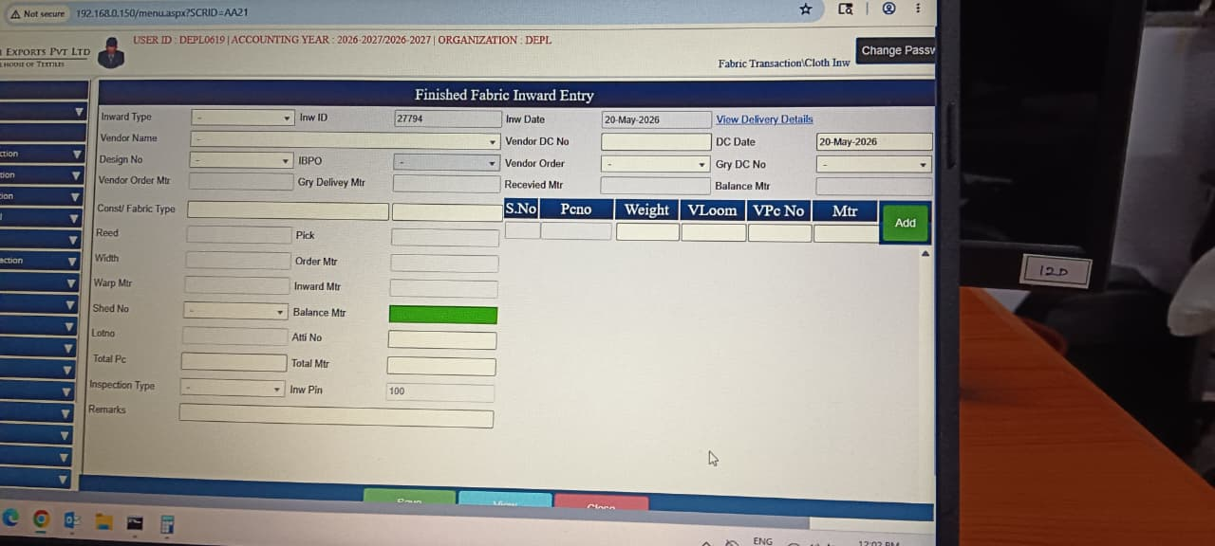
Finished Fabric Inward Entry

1. Purpose

The Finished Fabric Inward Entry module is designed to record and manage the inward movement of finished fabric received from vendors, job workers, or production units. It ensures proper tracking of quantities, inspection, and integration with buyer orders and inventory.
- Record Fabric Inward → capture inward ID, date, type, and vendor details.
- Track Order & Balance → monitor ordered meters, received meters, and balance meters.
- Link Buyer Orders & Designs → connect inward fabric to IBPO, design number, and lot details.
- Maintain Vendor Records → store vendor DC numbers, orders, and remarks.
- Support Quality Inspection → inspection type, reed, pick, width, and fabric type ensure QC compliance.
- Enable Logistics Integration → record shed number, inward pin, and transport references.
- Provide Reporting → generate inward summaries and vendor performance reports.

2. Main Functions

Fabric Inventory Tracking — enables the company to record inward entries of finished fabric and integrate them with QC, accounts, and dispatch.
This module records:
- Inward Identification → Inward ID, inward type, inward date, vendor DC number.
- Order & Design Linkage → IBPO, design number, vendor order, lot number.
- Quantity Management → vendor order meters, gry delivery meters, received meters, balance meters.
- Fabric Specifications → reed, pick, width, fabric type, total PCs.
- Inspection & QC → inspection type, inward pin, remarks.
- Logistics & Storage → shed number, inward location, storage references.
- Reporting & Audit → inward records, balance tracking, and audit logs.

3. Fields
Field Name | Purpose | What Should be Added
Inward Type | Type of fabric inward transaction | Select inward type such as Processing Return, Purchase, Job Work
Inv ID | Inward entry reference number | System/manual inward reference number
Inv Date | Inward transaction date | Select inward entry date
Vendor Name | Supplier / Job worker name | Select vendor or job worker name
Vendor DC No | Vendor delivery challan number | Enter vendor DC/challan number
DC Date | Delivery challan date | Select challan date
Design No | Fabric design reference | Select/enter fabric design number
IBPO | Internal buyer purchase order number | Enter/select IBPO reference
Vendor Order | Vendor order reference | Enter vendor order number
Vendor Order Mtr | Vendor ordered quantity in meters | Enter vendor order quantity
Grey Delivery Mtr | Grey fabric delivered quantity | Enter grey fabric delivery quantity
Received Mtr | Finished fabric received quantity | Enter actual received quantity
Balance Mtr | Pending quantity balance | System-calculated pending quantity
Const Fabric Type | Fabric construction/type | Enter/select fabric construction type
Reed | Reed specification | Enter reed specification
Pick | Pick specification | Enter pick specification
Width | Fabric width | Enter fabric width details
Order Mtr | Ordered fabric quantity | Enter total ordered meters
Warp Mtr | Warp length details | Enter warp length quantity
Inward Mtr | Inward fabric quantity | Enter inward received quantity
Shed No | Shed identification number | Enter/select shed number
Balance Mtr | Remaining balance quantity | System-calculated balance meters
Lot No | Fabric lot number | Enter/select lot number
Affi No | Reference/Affidavit number | Enter affidavit/reference number
Total PC | Total fabric pieces received | System-calculated total pieces
Total Mtr | Total meter quantity | System-calculated total meters
Inspection Type | Fabric inspection category | Select inspection type/category
Inv Pin | Inward approval/reference PIN | Enter inward approval PIN/reference
Remarks | Additional comments or notes | Enter inward remarks/comments

4. Grid/Table Field Explanation
Field Name | Purpose | What Should be Added
S.No | Serial number | System-generated serial number
Pc No | Fabric piece number | Enter fabric piece number
Weight | Weight of fabric piece | Enter piece weight
VLoom | Loom identification number | Enter loom/machine number
VPc No | Vendor piece number | Enter vendor piece reference
Mtr | Fabric length in meters | Enter received meters
Add | Add piece details to the grid | Click to add piece details into grid

5. Inspection & Quantity Verification Section
Field Name | Purpose | What Should be Added
Inspection Type | Type of fabric inspection performed | Select inspection category/type
Total PC | Total number of pieces received | System-calculated total pieces
Total Mtr | Total received meter quantity | System-calculated total meters
Received Mtr | Actual quantity received | Enter actual inward quantity
Balance Mtr | Quantity yet to be received | System-calculated pending quantity
Remarks | Inspection observations and comments | Enter inspection remarks/details

6. Vendor & Delivery Reference Section
Field Name | Purpose | What Should be Added
Vendor Name | Supplier or job worker name | Select vendor/supplier name
Vendor DC No | Vendor challan reference | Enter delivery challan number
DC Date | Delivery challan date | Select challan date
Vendor Order | Vendor order reference | Enter vendor order details
IBPO | Internal buyer order reference | Enter/select IBPO number
Design No | Fabric design reference | Enter/select fabric design
Lot No | Fabric lot tracking number | Enter/select lot tracking number

7. Buttons Function
Button | Purpose | What Should be Added
Save | Save inward transaction details | Click to save inward entry
View | View previously saved inward entries | Click to search/view inward records
Close | Exit the screen | Click to close inward screen
Add | Add fabric piece details to the grid | Click to add fabric piece details

Packing Slip Bale Entry
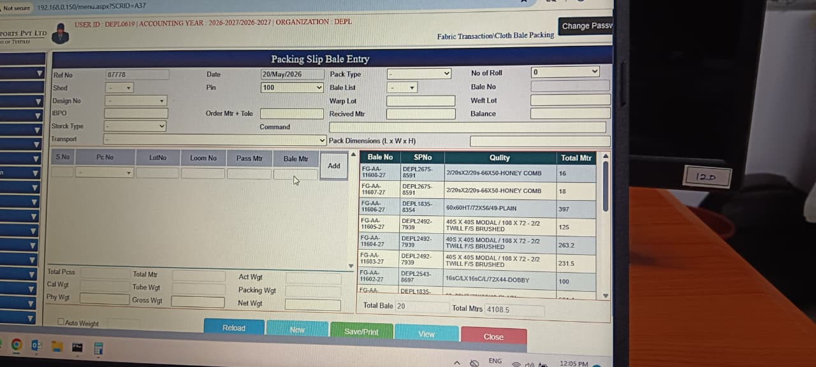

1. Purpose
The Packing Slip Bale Entry module is designed to manage and record the packing of finished fabric into bales for dispatch. It ensures accurate documentation of bale numbers, fabric specifications, and packing weights, while linking to buyer orders and logistics.
It helps to:
- Record Bale Packing → capture bale numbers, packing type, and dimensions.
- Track Fabric Quantities → monitor order meters, bale meters, and balance meters.
- Link Orders & Designs → connect packed bales to IBPO, design numbers, warp/weft lots.
- Maintain Bale Records → store bale IDs, quality details, and lot references.
- Support Logistics → record transport details, shed numbers, and packing dimensions.
- Enable Weight Tracking → calculate gross, net, tube, and physical weights for accuracy.
- Provide Reporting → generate bale summaries and dispatch readiness reports.

2. Main Functions
Packing & Dispatch Preparation — enables the company to record bale packing details and integrate them with inventory, accounts, and logistics.
This module records:
- Packing Identification → Ref No, Date, Pack Type, Shed, Design No, IBPO.
- Order & Lot Linkage → Order meters, warp lot, weft lot, lot numbers.
- Quantity Management → Bale meters, pass meters, total meters, balance meters.
- Fabric Quality Details → Quality specifications, loom numbers, bale summaries.
- Weight Tracking → calculated weights (gross, net, tube, physical, packing).
- Logistics Integration → transport details, packing dimensions (L × W × H).
- Reporting & Audit → total bales, total meters, and dispatch readiness.

3. Fields
Field Name | Purpose | What Should be Added
Ref No | Packing slip reference number | System/manual packing reference number
Date | Packing entry date | Select packing date
Pack Type | Type of packing | Select packing type/category
No of Roll | Number of rolls packed | Enter total roll quantity
Shed | Shed reference number | Select shed/location reference
Pin | Packing/approval code | Enter packing or approval reference
Bale List | Existing bale reference | Select existing bale details
Bale No | Bale identification number | Enter/generate bale number
Design No | Fabric design number | Select fabric design number
Warp Lot | Warp lot reference | Enter/select warp lot number
Weft Lot | Weft lot reference | Enter/select weft lot number
IBPO | Internal buyer purchase order | Enter/select IBPO number
Order Mtr + Tole | Ordered quantity with tolerance | Enter order quantity with tolerance
Received Mtr | Received fabric quantity | Enter received fabric meters
Balance | Pending quantity balance | System-calculated balance quantity
Stock Type | Stock category | Select stock type/category
Command | Packing remarks/comments | Enter packing comments or remarks
Transport | Transport details | Enter/select transport details
Pack Dimensions (L × W × H) | Bale package dimensions | Enter package length, width, and height

4. Grid/Table Field Explanation

Bale Entry Grid
Field Name | Purpose | What Should be Added
S.No | Serial number | System-generated serial number
Pc No | Piece number | Enter fabric piece number
Lot No | Fabric lot number | Enter/select lot reference
Loom No | Loom reference number | Enter loom/machine number
Pass Mtr | Approved fabric meters | Enter approved quantity in meters
Bale Mtr | Packed bale meters | Enter packed bale quantity
Add | Add roll details into bale | Click to add roll details into grid

Packed Bale Details Grid
Field Name | Purpose | What Should be Added
Bale No | Unique bale number | System/manual bale identification number
SP No | Stock/Packing reference number | Enter stock or packing slip number
Quality | Fabric quality specification | Enter/select fabric quality
Total Mtr | Total meters packed in bale | System-calculated packed quantity

5. Weight Calculation Section
Field Name | Purpose | What Should be Added
Total Pcs | Total pieces packed | System-calculated total pieces
Total Mtr | Total packed meters | System-calculated packed quantity
Act Wgt | Actual fabric weight | Enter actual measured fabric weight
Cal Wgt | Calculated weight | System-calculated fabric weight
Tube Wgt | Tube/core weight | Enter tube/core weight
Packing Wgt | Packing material weight | Enter packing material weight
Phy Wgt | Physical measured weight | Enter physically measured weight
Gross Wgt | Total gross weight | System-calculated gross weight
Net Wgt | Net fabric weight | System-calculated net weight
Auto Weight | Automatic weight calculation option | Tick/check for automatic weight calculation

6. Bale Summary Section
Field Name | Purpose | What Should be Added
Total Bale | Total number of bales packed | System-calculated bale count
Total Mtrs | Total fabric quantity packed | System-calculated packed meters
Bale No | Bale identification number | Display bale number details
Quality | Fabric quality details | Display fabric quality specification
Total Mtr | Quantity packed per bale | Display packed quantity per bale

7. Buttons Function
Button | Purpose | What Should be Added
Reload | Refresh current packing data | Click to reload latest packing details
New | Create new packing entry | Click to create new packing record
Save/Print | Save and print packing slip | Click to save and print packing slip
View | View existing packing entries | Click to search/view packing records
Close | Exit screen | Click to close packing screen
Add | Add roll details to bale | Click to add bale/roll item details

Goods Release Advoice
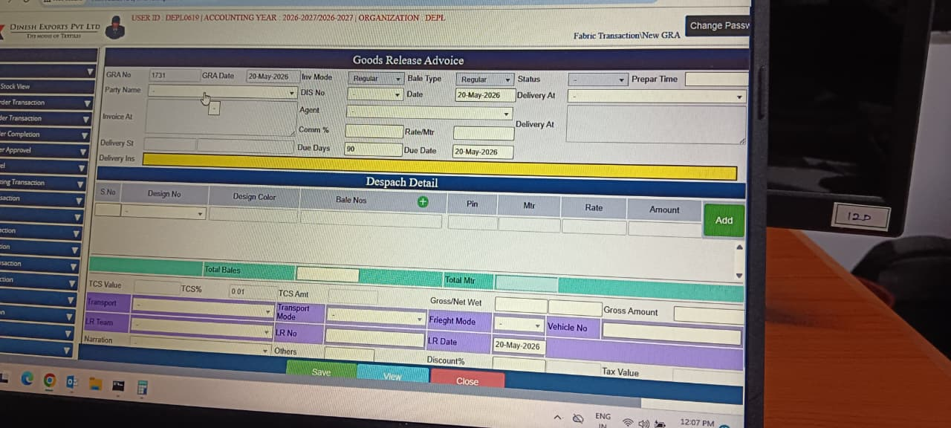

1. Purpose
The Goods Release Advice module is designed to manage and record the final release of finished fabric bales for dispatch to customers. It ensures proper linkage between production, accounts, and logistics by capturing bale details, invoice data, and transport information.
It helps to:
- Record Goods Release → capture invoice mode, bale type, and dispatch details.
- Track Bale & Fabric Details → monitor bale numbers, meters, rates, and amounts.
- Link Orders & Designs → connect dispatches to design numbers, colors, and buyer references.
- Maintain Financial Records → calculate gross/net weight, gross amount, discounts, tax, and TCS values.
- Support Logistics → record transport mode, vehicle number, LR date, and driver details.
- Enable Commission & Payment Tracking → agent commission, rate per meter, and due days.
- Provide Reporting → generate dispatch summaries and audit records.

2. Main Functions
Final Dispatch & Billing Control — enables the company to record goods release and integrate it with accounts, logistics, and customer delivery.
This module records:
- Dispatch Identification → invoice mode, bale type, DC details.
- Order & Design Linkage → design number, design color, bale numbers, pin references.
- Quantity & Rate Management → meters, rate per meter, gross/net weights.
- Financial Tracking → gross amount, discount %, tax value, TCS value, agent commission.
- Logistics Integration → transport mode, vehicle number, LR date, delivery details.
- Audit & Reporting → total bales, gross/net weights, dispatch summaries.

3. Fields
Field Name | Purpose | What Should be Added
GRA No | Goods Release Advice number | System/manual GRA reference number
GRA Date | GRA transaction date | Select GRA entry date
Inv Mode | Invoice mode/type | Select invoice mode such as Local, Export, Sample
Bale Type | Type of bale being dispatched | Select bale category/type
Status | Dispatch status | Select Open, Pending, Completed, Closed
Prepare Time | Preparation time | Enter dispatch preparation time
Party Name | Customer/buyer name | Select customer or buyer name
DIS No | Dispatch instruction number | Enter dispatch instruction reference
Date | Dispatch reference date | Select dispatch reference date
Delivery At | Delivery location | Select delivery destination/location
Invoice At | Invoice destination/location | Select invoice billing location
Agent | Agent or broker details | Select broker/agent name
Comm % | Commission percentage | Enter agent commission percentage
Delivery At (Address) | Delivery address | Enter full delivery address
Delivery SI | Delivery special instructions | Enter special delivery instructions
Delivery Ins | Delivery instructions | Enter dispatch/shipping instructions
Rate/Mtr | Fabric rate per meter | Enter selling rate per meter
Due Days | Payment credit days | Enter allowed credit days
Due Date | Payment due date | System/manual due date

4. Dispatch Detail Grid
Field Name | Purpose | What Should be Added
S.No | Serial number | System-generated serial number
Design No | Fabric design number | Select/enter fabric design number
Design Color | Fabric color reference | Select fabric color/shade
Bale Nos | Bale identification numbers | Enter/select bale numbers
Pin | Packing/approval reference | Enter packing or approval reference
Mtr | Fabric quantity in meters | Enter dispatch quantity in meters
Rate | Fabric rate | Enter fabric selling rate
Amount | Total amount | System-calculated line amount
Add | Add dispatch item to grid | Click to add dispatch item details

5. Dispatch Summary Section
Field Name | Purpose | What Should be Added
Total Bales | Total bales being dispatched | System-calculated bale quantity
Total Mtr | Total fabric quantity | System-calculated dispatch meters
Gross Amount | Total dispatch value | System-calculated gross amount
TCS Value | Tax collected at source value | System-calculated TCS value
TCS % | TCS percentage | Enter/select TCS percentage
TCS Amt | TCS amount | System-calculated TCS amount
Gross/Net Weight | Shipment weight details | Enter/display shipment weight

6. Transport & Logistics Section
Field Name | Purpose | What Should be Added
Transport | Transport company name | Select transport/logistics provider
Transport Mode | Mode of transportation | Select Road, Air, Rail, Courier, etc.
Freight Mode | Freight payment type | Select Paid, To Pay, COD, Self
Vehicle No | Vehicle registration number | Enter truck/vehicle number
LR Team | Logistics reference | Enter logistics team/reference details
LR No | Lorry receipt number | Enter LR/consignment number
LR Date | Lorry receipt date | Select LR date
Narration | Additional dispatch remarks | Enter dispatch remarks/comments
Others | Other logistics information | Enter additional logistics details

7. Tax & Discount Section
Field Name | Purpose | What Should be Added
Discount % | Discount percentage applied | Enter applicable discount percentage
Tax Value | Applicable tax amount | System-calculated tax amount
Gross Amount | Total invoice amount before adjustments | System-calculated gross amount
TCS Amount | Tax collected at source amount | System-calculated TCS amount

8. Buttons Function
Button | Purpose | What Should be Added
Save | Save Goods Release Advice transaction | Click to save GRA details
View | View previously saved GRA entries | Click to search/view GRA records
Close | Exit screen | Click to close GRA screen
Add | Add dispatch details to grid | Click to add dispatch item row

Sales Invoice
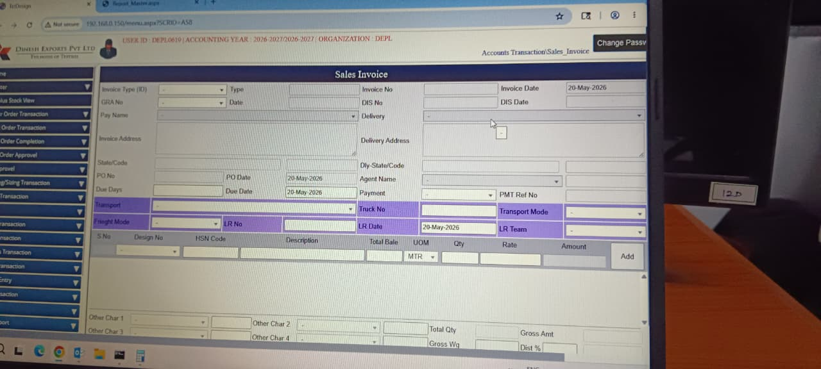

1. Purpose
The Sales Invoice module is designed to generate and manage customer billing documents for dispatched goods. It ensures proper linkage between buyer orders, delivery details, accounts, and logistics, while maintaining compliance with taxation and financial reporting.
It helps to:
- Generate Sales Invoices → capture invoice number, type, date, and buyer details.
- Link Orders & Deliveries → connect invoices to PO numbers, dispatch details, and LR dates.
- Maintain Financial Records → record rates, amounts, discounts, taxes, and payment terms.
- Support Logistics → include transport mode, vehicle details, and delivery addresses.
- Enable Compliance → ensure GST, TCS, and other statutory requirements are met.
- Provide Reporting → generate invoice summaries for accounts and audit purposes.

2. Main Functions
Customer Billing & Accounts Integration — enables the company to record sales invoices and integrate them with dispatch and accounts.
This module records:
- Invoice Identification → invoice type, invoice number, invoice date.
- Order & Buyer Linkage → PO number, buyer details, delivery address.
- Dispatch & Logistics → LR date, transport mode, vehicle details.
- Financial Tracking → rate per meter, gross/net amounts, discounts, tax values, TCS.
- Payment & Due Days → payment terms, due dates, agent commission.
- Audit & Reporting → invoice summaries, compliance records, and reconciliation with accounts.

3. Fields
Field Name | Purpose | What Should be Added
Invoice Type (ID) | Type of sales invoice | Select invoice type such as Local, Export, Debit Note
Type | Invoice category | Select sales category/type
Invoice No | Unique invoice number | System/manual invoice number
Invoice Date | Invoice creation date | Select invoice date
GRA No | Goods Release Advice reference | Enter/select GRA reference number
Date | GRA reference date | Select GRA date
DIS No | Dispatch instruction number | Enter dispatch instruction number
DIS Date | Dispatch date | Select dispatch date
Pay Name | Customer billing name | Select customer billing party
Delivery | Delivery location/customer | Select delivery party/customer
Invoice Address | Customer billing address | Enter billing address
Delivery Address | Delivery destination address | Enter delivery address
State/Code | Billing state and GST state code | Select billing state and GST code
Dly State/Code | Delivery state and code | Select delivery state and GST code
PO No | Customer purchase order number | Enter customer PO number
PO Date | Purchase order date | Select PO date
Agent Name | Sales agent/broker | Select agent or broker name
Due Days | Credit period days | Enter payment credit days
Due Date | Payment due date | System/manual due date
Payment | Payment method/terms | Select payment terms such as Cash, Credit, Advance
PMT Ref No | Payment reference number | Enter payment reference details

4. Transport & Logistics Section
Field Name | Purpose | What Should be Added
Transport | Transport company name | Select transport/logistics company
Truck No | Vehicle/truck number | Enter vehicle registration number
Transport Mode | Transportation method | Select Road, Rail, Air, Courier, etc.
Freight Mode | Freight payment type | Select To Pay, Paid, Self, COD
LR No | Lorry receipt number | Enter LR/consignment number
LR Date | Lorry receipt date | Select LR date
LR Team | Logistics reference/team | Enter logistics coordinator/team details

5. Invoice Item Details Grid
Field Name | Purpose | What Should be Added
S.No | Serial number | System-generated item serial number
Design No | Fabric design number | Select/enter fabric design number
HSN Code | GST HSN classification code | Enter HSN/SAC code
Description | Fabric description | Enter fabric/item description
Total Bale | Number of bales sold | Enter bale quantity
UOM | Unit of measurement | Select unit such as Mtrs, Kg, Pcs
Qty | Quantity sold | Enter invoice quantity
Rate | Selling rate per unit | Enter item selling rate
Amount | Total line amount | System-calculated item amount
Add | Add item to invoice | Click to add item into invoice grid

6. Additional Charges & Summary Section
Field Name | Purpose | What Should be Added
Other Char 1 | Additional charge type 1 | Enter/select extra charge details
Other Char 2 | Additional charge type 2 | Enter/select extra charge details
Other Char 3 | Additional charge type 3 | Enter/select extra charge details
Other Char 4 | Additional charge type 4 | Enter/select extra charge details
Total Qty | Total invoice quantity | System-calculated total quantity
Gross Wg | Gross weight of goods | Enter/display total gross weight
Gross Amt | Total invoice amount before deductions | System-calculated gross amount
Dist % | Discount percentage | Enter applicable discount percentage

7. Invoice Calculation Section
Field Name | Purpose | What Should be Added
Rate | Item selling rate | Enter item/unit rate
Amount | Item value | System-calculated line amount
Gross Amount | Total invoice value | System-calculated invoice gross value
Discount % | Discount applied | Enter discount percentage/value
Net Amount | Final payable amount | System-calculated payable amount
Tax Amount | GST and applicable taxes | System-calculated tax amount
Total Quantity | Total billed quantity | System-calculated invoice quantity

8. Buttons Function
Button | Purpose | What Should be Added
Save | Save sales invoice | Click to save invoice details
View | View existing invoices | Click to search/view invoice records
Close | Exit screen | Click to close invoice screen
Add | Add invoice item details | Click to add item row into invoice

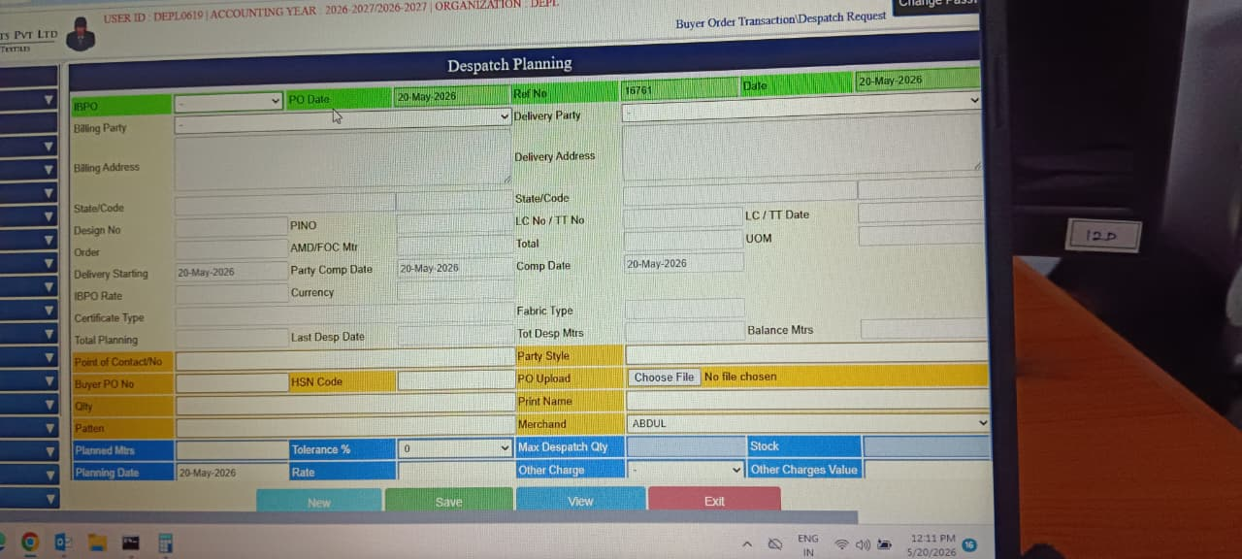
Despatch Planning

1. Purpose
The Despatch Planning module is designed to plan, schedule, and manage the dispatch of finished fabric orders to buyers. It ensures proper coordination between production, accounts, and logistics by capturing order details, planned meters, tolerance, and delivery schedules.
It helps to:
- Plan Dispatch Orders → capture IBPO, PO date, design number, and order meters.
- Track Balance & Planned Meters → monitor total dispatch meters, balance meters, and tolerance %.
- Link Buyer & Delivery Details → connect billing party, delivery party, and delivery address.
- Maintain Logistics Records → record transport mode, city, state, and HSN code.
- Support Financial Planning → capture rate, currency, other charges, and merchant details.
- Enable Scheduling → set delivery start date, party completion date, and planning date.
- Provide Reporting → generate dispatch plans for management and audit.

2. Main Functions
Dispatch Scheduling & Control — enables the company to plan dispatches in alignment with buyer orders and production readiness.
This module records:
- Order Identification → IBPO, PO date, Ref No, design number.
- Buyer & Delivery Linkage → billing party, delivery party, delivery address, point of contact.
- Quantity Planning → planned meters, tolerance %, max dispatch quantity, balance meters.
- Fabric & Stock Details → fabric type, pattern, stock availability.
- Financial Tracking → rate, currency, other charges, and merchant assignment.
- Logistics Integration → transport mode, city/state code, HSN code.
- Audit & Reporting → dispatch planning summaries, tolerance checks, and completion dates.

3. Fields
Field Name | Purpose | What Should be Added
IBPO | Internal Buyer Purchase Order number | Enter internal buyer PO number
PO Date | Purchase order date | Select buyer purchase order date
Ref No | Dispatch planning reference number | System/manual dispatch reference number
Date | Planning date | Select dispatch planning date
Billing Party | Customer billing party | Select billing customer name
Delivery Party | Delivery customer/consignee | Select delivery customer/consignee
Billing Address | Customer billing address | Enter billing address details
Delivery Address | Delivery destination address | Enter delivery address details
State/Code | Billing state and code | Select billing state and GST code
State/Code (Delivery) | Delivery state and code | Select delivery state and GST code
Design No | Fabric design reference | Select/enter fabric design number
PINO | Internal planning/order number | Enter internal planning number
Order | Customer order quantity | Enter total ordered quantity
AMD/FOC Mtr | Additional/Free of Cost quantity | Enter amendment/free quantity
Total | Total order quantity | System-calculated total quantity
UOM | Unit of measurement | Select unit such as Mtrs, Kg, Pcs
Delivery Starting | Planned delivery start date | Select delivery starting date
Party Comp Date | Customer committed date | Enter customer committed delivery date
Comp Date | Planned completion date | Select expected completion date
LC No / TT No | Letter of Credit / Telegraphic Transfer reference | Enter LC/TT reference number
LC / TT Date | LC/TT document date | Select LC/TT document date
IBPO Rate | Buyer order rate | Enter buyer agreed rate
Currency | Transaction currency | Select currency type such as INR, USD
Certificate Type | Export/quality certificate type | Select required certificate type
Fabric Type | Fabric category/type | Select fabric type/category
Total Planning | Total planned quantity | System/manual planned quantity
Last Desp Date | Last dispatch date | Display/select last dispatch date
Tot Desp Mtrs | Total dispatched meters | System-calculated dispatched quantity
Balance Mtrs | Remaining meters to dispatch | System-calculated pending quantity

4. Customer & Export Information Section
Field Name | Purpose | What Should be Added
Point of Contact/No | Customer contact person and number | Enter customer contact name and mobile number
Party Style | Customer style reference | Enter customer style/design reference
Buyer PO No | Buyer purchase order number | Enter buyer PO reference
HSN Code | GST HSN classification code | Enter GST HSN/SAC code
PO Upload | Upload customer purchase order document | Upload scanned PO document/file
City | Customer city | Enter/select customer city
Print Name | Name to appear on documents | Enter printing/display name
PAN | Customer PAN number | Enter customer PAN details
Merchant | Assigned merchandiser/executive | Select assigned merchandiser name

5. Planning & Quantity Control Section
Field Name | Purpose | What Should be Added
Planned Mtrs | Planned dispatch quantity | Enter planned dispatch meters
Tolerance % | Allowed quantity tolerance percentage | Enter allowed tolerance percentage
Max Dispatch Qty | Maximum dispatch quantity allowed | System/manual maximum dispatch quantity
Stock | Available stock quantity | Display available stock quantity
Planning Date | Dispatch planning date | Select planning entry date
Rate | Selling rate | Enter dispatch/selling rate
Other Charge | Additional charge type | Select additional charge category
Other Charges Value | Additional charge amount | Enter additional charge value

6. Buttons Function
Button | Purpose | What Should be Added
New | Create new dispatch plan | Click to create new dispatch planning entry
Save | Save dispatch planning details | Click to save dispatch planning information
View | View existing dispatch plans | Click to search/view dispatch records
Exit | Close the screen | Click to close dispatch planning screen

Employee Master
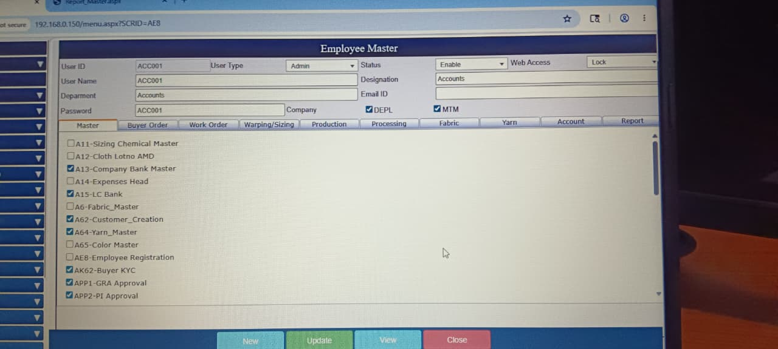

1. Purpose
The Employee Master module is designed to manage and control user accounts, roles, and access rights within the ERP system. It ensures proper assignment of responsibilities, secure access, and integration of employees into different operational modules.
It helps to:
- Create & Manage User Accounts → define user IDs, names, departments, and designations.
- Control Access Rights → enable/disable status, web access, and lock/unlock accounts.
- Assign Roles & Permissions → set user type (Admin, Manager, Operator) and module access.
- Maintain Company Associations → link employees to one or multiple companies (e.g., DEPL, MTM).
- Support Compliance & Security → enforce password policies and audit user activity.
- Enable Communication → store employee email IDs for system notifications.
- Provide Reporting → generate employee access logs and master records.

2. Main Functions
User & Role Management — enables the company to configure employee details and control ERP access.
This module records:
- User Identification → User ID, user name, department, designation.
- Access Control → status (enable/disable), web access, lock/unlock.
- Role Assignment → user type (Admin, Manager, Staff), assigned modules.
- Company Linkage → employee association with one or multiple companies.
- Module Permissions → access to masters, buyer orders, work orders, production, accounts, reports.
- Security & Compliance → password setup, audit trails, and KYC approvals.
- Reporting & Updates → employee registration, updates, and view logs.

3. Fields
Field Name | Purpose | What Should be Added
User ID | Unique login ID for employee/system user | Enter unique employee login ID
User Name | Employee or user name | Enter employee full name
User Type | Defines role type such as Admin/User | Select role like Admin, User, Manager, Operator
Status | Enable or disable user account | Select Enable or Disable status
Web Access | Allow or restrict web login access | Select Allow/Lock web access
Department | Employee department name | Select department such as Accounts, Production, Stores
Designation | Employee job role/designation | Enter employee designation/job title
Email ID | Employee official email address | Enter official employee email ID
Password | User login password | Enter secure login password
Company | Company access selection | Select accessible company names
DEPL | Access permission for DEPL company | Tick/check if access is allowed
MTM | Access permission for MTM company | Tick/check if access is allowed

4. Module Access Permission Section
This section is used to assign menu-wise access permissions for each employee.
Tab Name | Purpose | What Should be Added
Master | Access to master setup screens | Enable master module access
Buyer Order | Access to buyer order operations | Enable buyer order transaction access
Work Order | Access to work order processing | Enable work order management access
Warping/Sizing | Access to warping and sizing modules | Enable warping and sizing operations
Production | Access to production activities | Enable production module access
Processing | Access to processing operations | Enable processing activity access
Fabric | Access to fabric management | Enable fabric-related operations
Yarn | Access to yarn-related modules | Enable yarn management access
Account | Access to accounts and finance modules | Enable accounts and finance access
Report | Access to reporting section | Enable report viewing/export access

5. Permission Fields/Menu List
Menu Name | Purpose | What Should be Added
A11-Sizing Chemical Master | Manage sizing chemical details | Permission to create/edit sizing chemicals
A12-Cloth Lotno AMD | Manage cloth lot amendment details | Permission for cloth lot amendments
A13-Company Bank Master | Maintain company bank account details | Permission to manage company bank data
A14-Expenses Head | Define expense categories/heads | Permission to create/edit expense heads
A15-LC Bank | Maintain Letter of Credit bank details | Permission to manage LC bank information
A6-Fabric_Master | Maintain fabric master information | Permission to manage fabric master records
A62-Customer_Creation | Create and manage customer details | Permission to create/edit customer records
A64-Yarn_Master | Maintain yarn master information | Permission to manage yarn master data
A65-Color Master | Manage color master details | Permission to create/edit color details
AE8-Employee Registration | Employee registration management | Permission to manage employee records
AK62-Buyer KYC | Maintain buyer KYC documents/details | Permission to manage buyer KYC data
APP1-GRA Approval | Approval access for GRA process | Approval permission for GRA transactions
APP2-PI Approval | Approval access for PI process | Approval permission for PI transactions

6. Buttons Function
Button | Purpose | What Should be Added
New | Create new employee/user record | Click to create new employee entry
Update | Save or update employee details | Click to save modified employee details
View | View existing employee records | Click to search/view employee information
Close | Exit and close the screen | Click to close Employee Master screen

Log Report

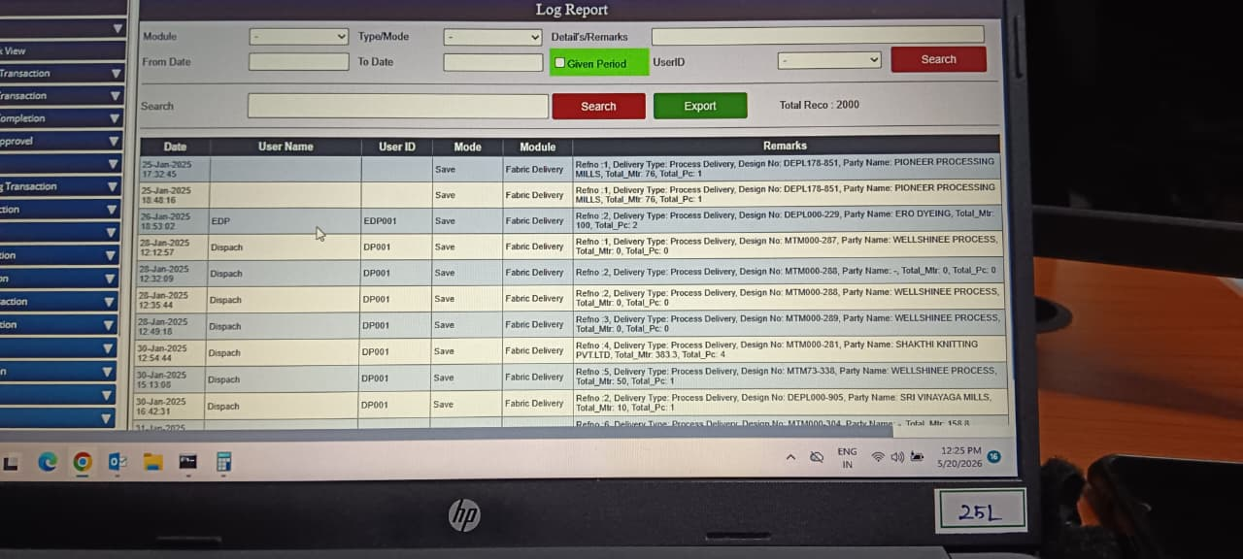

1. Purpose
The Log Report module is designed to track and monitor user activity and system transactions across the ERP. It ensures transparency, accountability, and audit readiness by recording detailed logs of operations performed by each user.
It helps to:
- Record User Activity → capture date, user ID, user name, and module accessed.
- Track Transaction Details → log remarks, delivery types, design numbers, and party names.
- Enable Audit & Compliance → provide traceability for approvals, edits, and deletions.
- Support Security Monitoring → detect unauthorized or unusual activity.
- Provide Reporting → export logs for management review and compliance checks.
- Improve Operational Transparency → show who performed which action and when.

2. Main Functions
System Audit & Activity Tracking — enables the company to monitor ERP usage and ensure accountability.
This module records:
- Log Identification → date, user name, user ID, mode of operation.
- Module Access Tracking → which ERP module was accessed (e.g., Fabric Delivery).
- Remarks & Details → transaction remarks, delivery type, design number, totals.
- Period Filtering → from/to date, given period checkbox for time-bound reports.
- Search & Export → filter logs by user, module, or type and export results.
- Audit & Compliance Reporting → generate summaries for management and statutory audits.

3. Fields
Field Name | Purpose | What Should be Added
Module | Select ERP module for log filtering | Select module name such as Fabric Delivery, Production, Accounts, Buyer Order, etc.
Type/Mode | Select transaction type/action mode | Select action type like Save, Update, Delete, Approval, Edit, Print
Detail's/Remarks | Search based on remarks/details | Enter transaction remarks, reference number, design number, or party name
From Date | Starting date for log search | Select beginning date for report filtering
To Date | Ending date for log search | Select ending date for report filtering
Given Period | Filter logs within selected period | Tick/check option to enable date-wise filtering
UserID | Filter records by specific user | Select or enter employee/user login ID
Search | Search keyword/filter option | Enter keyword for searching transaction details
Total Reco | Total number of records displayed | System-generated total record count

4. Log Details Section
Field Name | Purpose | What Should be Added
Date | Transaction date and time | System-generated transaction date and time
User Name | Name of employee/user | Employee or user name who performed activity
User ID | System login ID of user | Login/user ID of employee
Mode | Action performed such as Save/Update/Delete | Transaction action performed in system
Module | ERP module where action was performed | Module name where transaction occurred
Remarks | Detailed transaction/activity information | Reference details, design number, party name, quantity, process details, etc.

5. Remarks Information Purpose
The Remarks section stores detailed operational information such as:
- Reference number
- Delivery type
- Design number
- Party/customer name
- Total meters
- Total pieces
- Transaction details
- Processing remarks
This helps management trace complete transaction history for verification and auditing purposes.

6. Buttons Function
Button | Purpose | What Should be Added
Search | Retrieve log records based on filters | Click to fetch filtered log records
Export | Export log report to Excel or file format | Click to download/export report
Close/Exit | Close the screen | Exit from Log Report screen

